|  |
| --- |
| university of michigan-dearborn college of engineering and computer science department of electrical and computer engineering |
| CIS695 Final Report |
| Peninsula Velo Cycling Club Web 2.0 Website Project |
|  |
| **Csaba Nemeth** |
| **12/1/2010** |

|  |
| --- |
| This document contains the final report for the Peninsula Velo Cycling Club—http://penvelo.org—web 2.0 website project. |

# Revision History

Table : Revision History

| Date | Description | Responsible Person |
| --- | --- | --- |
| 01/18/2010 | Created document | Csaba Nemeth |
| 2/6/2010 | Progress report #1 | Csaba Nemeth |
| 2/15/2010 | Progress report #2 | Csaba Nemeth |
| 2/22/2010 | Progress report #3 | Csaba Nemeth |
| 3/7/2010 | Progress report #4 | Csaba Nemeth |
| 3/18/2010 | Progress report #5 | Csaba Nemeth |
| 3/28/2010 | Progress report #6 | Csaba Nemeth |
| 4/6/2010 | Progress report #7 | Csaba Nemeth |
| 5/29/2010 | Progress report #8 | Csaba Nemeth |
| 6/12/2010 | Progress report #9 | Csaba Nemeth |
| 7/1/2010 | Progress report #10 | Csaba Nemeth |
| 12/1/2010 | Final report | Csaba Nemeth |

## Signatures of Approval

__________________________________ __________________________________

Professor Adnan Shaout, Ph.D.,   
faculty advisor

__________________________________ __________________________________

Table of Contents

Revision History 2

Signatures of Approval 3

Table of Figures 8

List of Tables 9

Introduction 10

Target Audience 10

Project Team Members 10

Background 10

The Existing Website 10

The New Website 10

Current Project Status 10

Poject Overview 11

TEAM Organization 11

Development Method 11

Development Framework 12

Development Method 14

Application Runtime Environments 14

Logging 15

Debugging 15

Testing 15

Development Tools 15

Code Repository 21

Website Hosting 22

Deliverables and Timing 24

Risk Mangement 24

Hosting Risk 24

Knowledge Risk 25

Feasibility 25

Application Design 26

High-level Application Architecture 26

Web site Structure 26

Page Layout 27

Layout Design of Public Pages 27

Layout Design of Admin Pages 28

View Partials 29

Database Schema and Class Diagrams 29

Ruby Gems and Plugin Modules 32

User Authentication 33

Role-Based Authorization 33

Form Handling and ValidatioN 33

File Upload 33

Searching 33

Miscellaneous 33

Testing 33

Future Development 33

Conclusion 33

Definitions, Acronyms and Abbreviations 34

References 35

APPENDIX A: WEBSITE STRUCTURE DESCRIPTION 37

NON-ADMIN LAYOUT 37

ADMIN LAYOUT 37

PUBLIC ACCESS CONTENT 37

INDIVIDUAL PAGE DETAILS—MAIN CONTENT AREA 38

RISTRICTED ACCESS CONTENT—Level 1 39

RISTRICTED ACCESS CONTENT—Level 2 39

Appendix B: Main Use cases 41

Notes and Assumptions 41

General Use Cases 42

Use Case 1: Processing Requests and Responses—System Level, White Box 42

Use Case 2: Login—System level, black box 43

Use Case 3: Logout—System level, black box 44

Use Case 4: Register User—System level, black box 45

Use Case 5: Upload User Photo FIle—System level, Black Box 46

Use Case 6: Search for User by Last Name—System level, Black Box 47

Registered User Use Cases 48

Use Case 7: Edit User Profile—System level, black box 48

Use case 8: Download Document—System level, black box 49

Use Case 9: Create Post—System level, black box 50

Use Case 10: Add Comment—System level, black box 51

Admin (CRUD) Use Cases 51

Use Case 11: Manage Data—System level, black box 52

Use Case 12: Create New Or Edit Existing Record—System level, black box 53

Use Case 13: Show Record—System level, black box 54

Use Case 14: Delete Record—System level, black box 55

Appendix C: Rails Application Structure 57

Appendix D: List of Ruby Gems and Plugins Installed on Development System 60

*** LOCAL GEMS *** 60

Plugins 61

Appendix E: Screen Shots 62

# Table of Figures

Figure 1: The agile software development model [5] 12

Figure 2: MVC architecture for web development frameworks [13] 12

Figure 3: The Rails MVC architecture (Adapted from [13]) 13

Figure 4: An example of a web page with CRUD functionality generated by Rails’ scaffold command. 14

Figure 5: Linux console running the web server displaying the development log 17

Figure 6: The application development console 18

Figure 7: The interactive Rails console. 19

Figure 8: The database console 20

Figure 9: The GEdit text editor 21

Figure 10: The Penvelo project's Github repository 22

Figure 11: The Heroku project page 23

Figure 12: The Penvelo application running on Heroku.com 24

Figure 13: High-level design of the Penvelo website application 26

Figure 14: The Penvelo website structure 27

Figure 15: Public home page layout design 28

Figure 16" Admin home page layout design 29

Figure 17: ORM class diagram 30

Figure 18: Controller class diagram 31

Figure 19: The database schema for the penvelo.org web 2.0 website 32

Figure 20: Rails application default directory structure as shown in the Nautilus file browser 57

Figure 21: The application’s Home page 62

Figure 22: The login dialog 63

Figure 23: Login dialog showing login error 'login name' incorrect 63

Figure 24: User logged in with basic (non-admin) privileges 64

Figure 25: User logged in with admin privileges. 65

Figure 26: Logout confirmation dialog 66

Figure 27: The About page 66

Figure 28: The Club Rides page with an interactive Google Map imbedded in the page 67

Figure 29: The RIDE page fails to load on the Heroku site for lack of proper Google Maps API key 67

Figure 30: The Documents and Forms download page 68

Figure 31: The Edit My Account form 69

Figure 32: The edit my account form with error message on top and the problem fields highlighted in red 70

Figure 33: User profile page after being edited with update successful message on top 71

Figure 34: The Members page showing the result of search-by-lastname operation. 72

Figure 35: The POSTS page listing member-posted messages in reverse chronological order 72

Figure 36: Users can post comments to existing posts 73

Figure 37: The Club News page listing news items in reverse chronological order 73

Figure 38: The RSS feed page 74

Figure 39: A typical admin page with CRUD (Create, Read, Update, Delete) functionality 74

Figure 40: The 'Create New ...' form 75

Figure 41: The 'Edit' form 75

Figure 42: Deleting a record from the table 76

# List of Tables

Table 1: Revision History 2

Table 2: Team member roles and responsibilities 11

Table 4: Project deliverable and timing 24

Table 5 Abbreviations and acronyms 34

Table 5: Directory structure of a Rails application [13] Chapter 15.2, page 253 58

# Introduction

The purpose of this project is twofold. One is to satisfy graduation requirements for the Master of Science in Software Engineering program at the University of Michigan-Dearborn College of Engineering and Computer Science Department of Electrical and Computer Engineering, and the other is to create new website for the Peninsula Velo Cycling Club located in the San Francisco bay Area, California.

## Target Audience

The intended target audience for this document is the project panel for the CIS695 Master’s Project class, including Professor Adnan Shaout, Ph.D. who is the faculty advisor for this project.

## Project Team Members

The project team comprises a single member (self) whose name is listed on the title page and in the “Responsible Person” column in Table 1: Revision History.

## Background

This software project originated in September 2009 when the Board of Directors of the Peninsula Velo Club (http://penvelo.org/) decided it was time to replace the existing website because of it was outdated and did not meet the needs of the membership. I volunteered for the assignment and was given a clean sheet for the design and implementation of the new website.

## The Existing Website

The existing website is outdated in its looks and functionality. It was constructed using basic html, embedded style sheet (CSS), and some JavaScript for creating a basic image rollover effect. It has no database backend. It is also cumbersome to maintain and update with any new information because there is no user interface for performing administrative functions.

## The New Website

The objective for the redesign is to bring the club’s website up to current web 2.0 standards. This includes using a modern web development framework, database backend storage, user-driven content generation, and ease of maintainability through a web interface that requires authentication and authorization for security and access control, respectively. Furthermore, the redesigned look should provide a better showcase for the club and its commercial sponsors in order to attract new club members and customers to club sponsors.

## Current Project Status

Version 1.0 of the new website is ready for rollout into production. However, the ISP for production site has not been selected by the club so the application is currently running on the development server only. The implemented features include

* All information driving the website is stored in a MySQL database backend and virtually all information displayed on the web pages is retrieved from the database
* Public pages provide commonly accessible information about the club and its members
* Access is restricted to members-only information and to the administration sub-section of the site based on the logged in user’s role(s) within the club
* New club members can register with the website and existing users can administer their own profiles online, including uploading a photo of themselves that is displayed on with their (public) profiles
* Existing users can login with their username and password to access site content according to their role(s) within the club, including downloading club documents and forms
* The website menus are dynamically loaded based on the user role
* Registered users can post to the site which other users can comment on
* Users with administrative privileges can add new content to, edit and delete existing content from the database tables
* The site incorporates Google maps and a multimedia player on selected pages

# Poject Overview

The aim of this project—besides delivering a new website application—was also to learn about new technologies and development tools; hence, the choice of Ruby on Rails—RoR or simply Rails—as the development framework. Rails is a thoroughly modern Model-View-Controller (MVC) framework based on the fully object-oriented Ruby programming language both of which are relative new and will be described in more details in later sections. Both Rails and Ruby are radically different from the traditional C/C++-based programming languages, and as such, they require a paradigm shift in thinking on the part of the software engineer and developer. Needless to say, this provided an additional significant challenge—and risk--to the development effort.

## TEAM Organization

The project team—member roles and responsibilities are described in Table 2 below—comprised a single person, me. Besides the UMD academic panel, I am also responsible to the club leadership, which ultimately is responsible for signing off on the new website. Note that having just one more team member would have greatly improved the development process because it would have enabled pair programming in which one team member writes application code and the other writes tests that immediately verifies the correctness of the application code. Again, Rails is ideally suited for pair programming because tests are an integral part of Rails applications right from the get go as will be discussed later.

Table : Team member roles and responsibilities

| Name of Group Member | Primary Role | Other Responsibilities |
| --- | --- | --- |
| Csaba Nemeth | * Requirements Analyst * Software Architect * Database designer * Ruby on Rails developer * Software Tester * Technical writer | * Project coordinator * Repository maintainer * Website administrator |

## Development Method

Rails development is naturally suited to the agile software development method; therefore, this project followed a quasi agile method, closest maybe to eXtreme Programming (XP) comprising short iteration cycles, in which each cycle delivers a new functionality listed in the requirements document. This is illustrated in Figure 1 below.

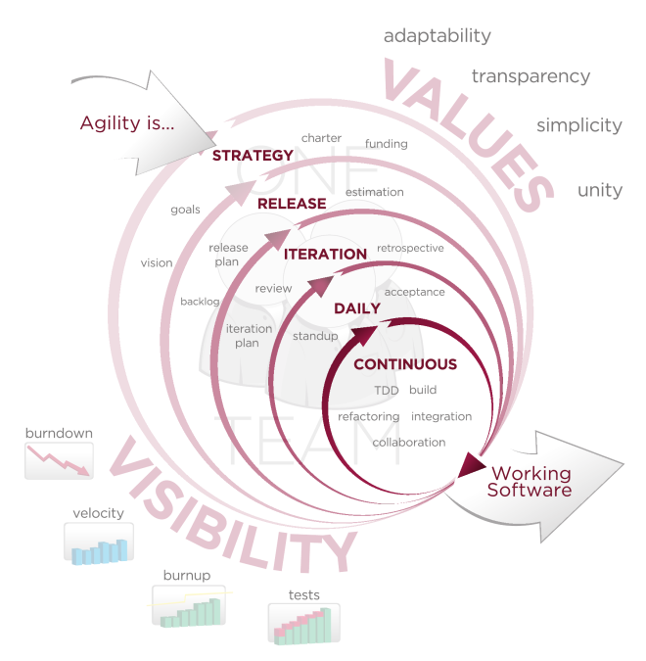

Figure : The agile software development model [5]

## Development Framework

There are a number of web development frameworks and content management systems (CMS)—both closed-source and open-source—which were created for the development of dynamic database-driven web applications. Some examples are Microsoft ASP.NET/Silverlight for Visual Basic or C#, Drupal based on PHP, Spring for Java and .NET, Apache Struts/Struts2 based on Java, and Ruby on Rails based on Ruby. Most of these frameworks employ the Model-View-Controller (MVC) architecture [13] show in Figure 2 below and Rails is no exception.

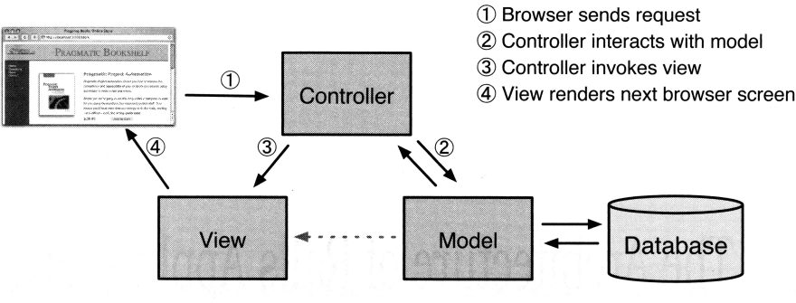

Figure : MVC architecture for web development frameworks [13]

Rails [7] is a relatively new framework for database-driven web application development created by David Heinemeier Hansson [3] and is based on the fully Object-Oriented Ruby programming language [6] created by Yukihiro “Matz” Matsumoto [2]. Both Ruby and Rails are open-source and freely available.

As mentioned earlier, Rails also employs the Model-View-Controller (MVC) architecture, albeit, in a slightly modified form shown in Figure 3 below. The only difference is that Rails adds a Router component, which maps incoming requests from web the browser into the appropriate controller method. This process is described in detail in Use Case 1: Processing Requests and Responses—System Level, White Box on page 33.

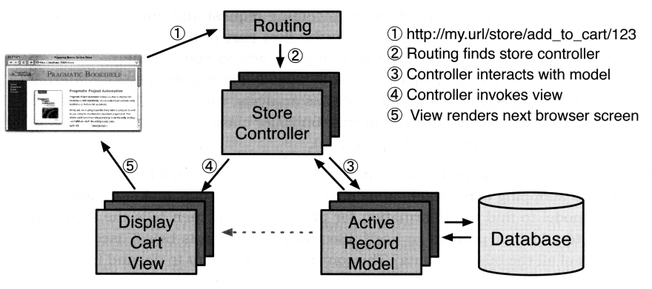

Figure : The Rails MVC architecture (Adapted from [13])

Rails follows the “Convention Over Configuration” and the “Don’t Repeat Yourself” principles [13]. “Convention Over Configuration” means that as long as the developer follows the Rails conventions—naming conventions and the way Rails lays out the structure of the application—there is very little need to do any configuration, unlike in other frameworks. For example, when developing a web application using the PHP-based Drupal framework almost all of the work done goes into configuring the various components of the application, which can get quite complex. “Don’t Repeat Yourself” means that there is rarely, if ever, a need to repeat the same code in different parts of the application.

Rails is also very efficient. Using two simple commands—script/generate scaffold … and rake db:migrate—Rails generates a controller, model and views complete with CRUD functionality and the underlying database table without any additional programming. An example of this is shown in Figure 4 below. In this webpage, an administrator can create new users, delete existing users, and edit and view information about existing users.

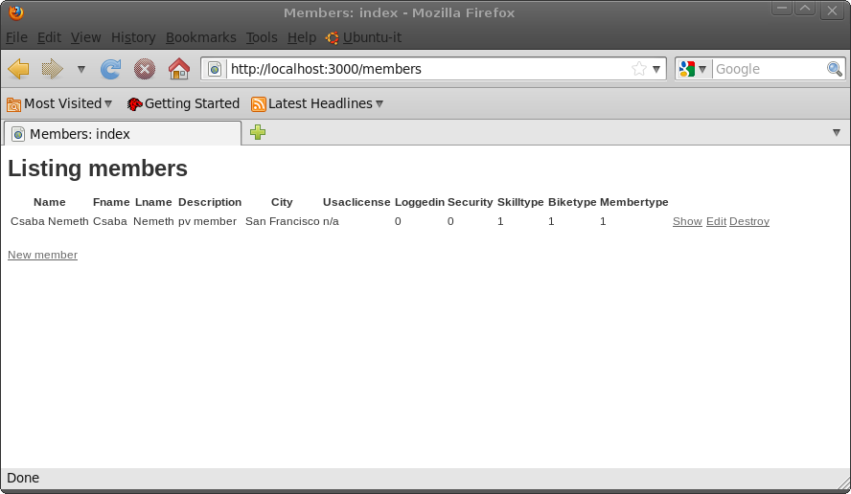

Figure : An example of a web page with CRUD functionality generated by Rails’ scaffold command.

The Rails framework is also highly modular. Rails is made up of several Ruby modules called gems (see Appendix D: List of Ruby Gems and Plugins Installed on Development System) and, therefore, is easy to extend by installing gems provided by third party developers. Ruby gems are managed by a Ruby gem called ‘rubygems-update’ and are easy to install from the command line using the following command (sudo may be required on some systems)

$ gem install rubygems-update

In general, Rails applications use several third-party gems and/or plugins that extend the base system and provide some needed functionality. This encourages code reusability by leveraging work done by other developers who made their work—usually well written and tested and free of chage—available to the Rails community. These gems are available for download through the internet from websites such as Github.com, RubyGems.org, etc. The Penvelo application is no different from other Rails applications and uses several third-party gems and plugin to provide functionality, for example, authentication, role-based authorization, multi-media player, etc.

The Rails framework has the following major components, which will be discussed in detail in the following sections.

* ActionPack
  + ActionController-handling and processing incoming browser requests
  + ActionView—handling and processing output (turning embedded ruby templates in to html pages that get sent to the browser and displayed as web pages)
* ActiveRecord—ORM layer mapping database tables into Rails objects.

In addition to the above, any discussion about Rails must mention routing and migrations. Also, the default directory structure of a Rails application is described in detail in Appendix C: Rails Application Structure on page 58.

Note: The following sections discussing the inner workings of Rails draw heavily on the book, Agile Web Development with Rails, Part III—Working With the Rails Framework .

### The ActionController Module

The top level class in every Rails application is the ApplicationController derived from the ActionController base class. All other controller in the application use the ApplicationController as their base class. Models—the ORM layer—are derived from the ActiveRecord base class. Both Models and Controllers can be enclosed in a name space. View templates are processed by the Embedded Ruby templating mechanism ERb (see Use Case 1 on page 33).

### The ActionView Module

$ …

### The ActiveRecord Module and

$ … ORM ..

### Migrations

$ …

### Routing

$ …

## Development Method

### Application Runtime Environments

By default, Rails applications can run in three types of runtime environment: production, development and test. In addition, each environment has its own database as defined in the databse.yml file in the config directory of the application. The configuration settings that control the runtime environment are also contained in the files also located in the config directory of the application but the switch that changes the environment is external to the application—it is specified when starting the web server and is server dependent. This is very convenient for the Rails developer for two reasons. One, there is no need to change application code when changing the runtime environment. And two, when running in development mode, the Rails dispatcher automatically reloads the application every time a request is made to it, which ensures that the developer always runs the latest version of the code.

### Logging

When developing Rails applications, log messages can be extremely helpful. Needless to say, Rails has built in facility for logging. The Rails framework provides a logger object that is exposed to all code in the application. For example, Figure 5 below shows the console window running the web server and displaying the content of the server log. Furthermore, the developer can generate four levels of log messages: warning, info, error and fatal, which get written into the runtime environment’s log file. (Each runtime has a separate log, plus the sever log located in the application’s log directory.)

### Debugging

Rails provides an interactive Ruby console, irb, invoked by the ./script/console command shown in Figure 7 below. Here the developer can interact with the application, and test code a routes. Analogous to the irb console, there is also an interactive database console invoked by the ./script/dbconsole command shown in Figure 8. Also, using the debug helper method, the developer can dump the state of the offending object passed from the controller, e.g., <%= debug(@user) %>. And finally, it is possible simulate break points by inserting debug statements into the code where at the location of the desired break point and restart the server with the –u (or --debugger) switch. When the application gets to the break point, in the consol window where the server is running, a ruby-debug session will open where the developer can examine the state of the application, e.g., list source, examine variables, set other break points, etc.

### Testing

Testing is also an integral part of Rails. As mentioned above, there is test run time environment with its own database, and there are significant resources dedicated to automated testing located in the application’s test directory. As a matter of fact, every time we run a generator script to create a model, controller or scaffold, the corresponding test files are generated for automated testing in the functional and unit subdirectories under test. The test directory contains five subdirectories: functional, integration, unit, performance and fixtures. The fixtures subdirectory contains .yml files for loading test data into the test database. These pre-generated files contain skeletal code so we do need to write code. Once we have the automated tests ready, we can use rake tasks to run the tests.

## Development Tools

Besides being free, the Linux OS—and Mac OS X, which is also based on the Linux kernel—are ideally suited for Rails application development. Although it can certainly be done, under Windows, setting up the Rails development environment is a bit more complex than and not as natural as under Linux and the Mac OS. Therefore, it was an easy choice to select Linux—namely the Ubuntu 10.04 (Lucid Lynx) 64-bit OS—as the development platform. The development system tools used for this project include the following

* Hardware
  + HP Pavillion Dv9700t laptop with external display, keyboard and mouse
* Software
  + Ubuntu (Linux) 10.04 64-bit operating system
  + Mongrel web server
  + Git v1.7.0.4 source code repository and version control system
  + Ruby version 1.8.7
  + Ruby on Rails web development framework version 2.3.8 with added plugins and gems (listed in Appendix B: Ruby Gems Installed on Development System) providing additional functionality
  + MySQL server version 5.1.41-3ubuntu12.7
  + Mozilla Firefox and Google Chrome web browsers
  + GEdit text editor with GMate plugin
  + Multiple Linux consoles pointing to the applications root directory
* Documentation, Presentation and Demo
  + Microsoft Word 2007—this document
  + Microsoft Visio 2007—page layout and database schema diagram
  + Microsoft PowerPoint 2007—project presentation
  + RDoc [37]—documentation generator for Ruby source code written by Dave Thomas [34]
  + GIMP (GNU Image Manipulation Program) [36]—all PNG files, screen shots
  + RailRoad class diagram generator [35]—used to generate model and controller class diagrams
  + recordMyDesktop [38]—for recording multimedia project demo on Linux
  + Annotate Ruby gem [47]—used for annotating models (with schema) in the source code

As it is apparent from the above list, another great thing about Rails application development is that it requires no complex and expensive development tools. A console window to the command line pointing to the application’s root directory, a text editor and a web browser will suffice. Although there are integrated development environments (IDE) available for Rails development, the best way to learn to develop Rails applications is to use the command line tools and a text editor that has Ruby/RoR syntax highlighting capability and other convenient features for code editing.

In a typical case, I have a console windows open with four tabs alongside the text editor and the web browser so having lots of screen real estate is important. Being connected to a high-speed Internet connection is also important because during Rails development one is almost constantly searching for examples and solutions to various issues, downloading gems and plugins, and viewing tutorials and screencasts on how to implement a particular feature or use a certain plugin.

The following figures illustrate the Rails application development process and the tools I used.

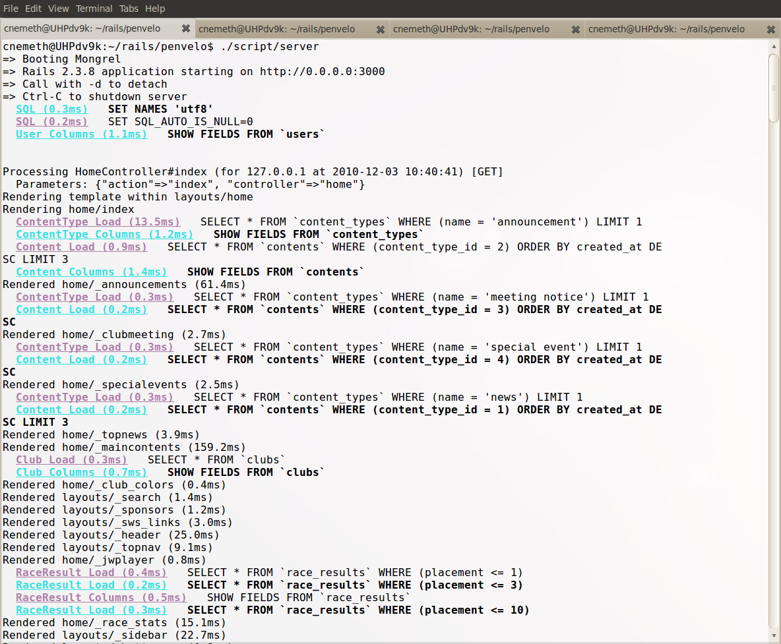

Figure : Linux console running the web server displaying the development log

Figure 5 above shows a Linux console that runs the web server and where we can see the lines from the development log scroll by during development. Rails has a default web server built in called WEBrick but if there is another web server installed on the system—like in this case Mongrel—Rails will use that instead. We can still force Rails to use the default web server by specifying in on the command line when we start the server:

$ ./script/server WEBrick

Rails development is also highly database-centric and Rails has excellent tools for working with the applications underlying database and data structures.

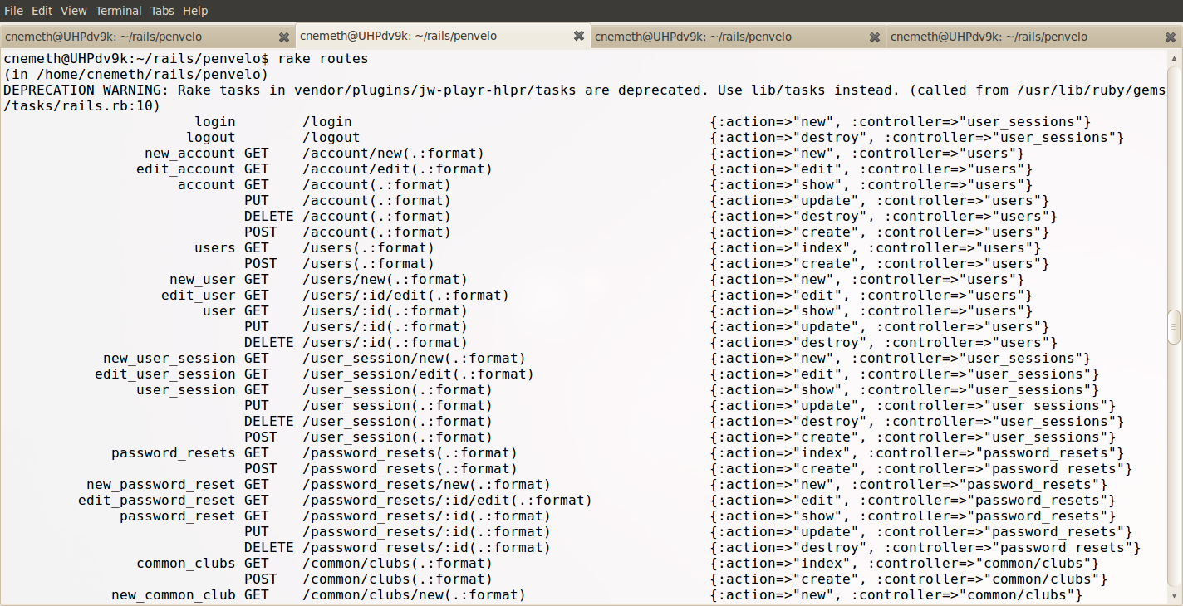

Figure : The application development console

Figure 6 above shows the console where the various generator scripts and the rake tool are being run during application development. The output shown is the output of the 'rake routes' command that displays all the available routes for the application.

Rails applications are generated by running various generator scripts written in Ruby. The application itself is generated by a script. For example,

$ rails app_name

will generate the application skeleton for the Rails application called app_name. In addition we can generate scaffolds, controllers, models and views. For example,

$ ./script/generate scaffold users name:string password:string

will create a migration file that defines the database table users with attributes name and password, both string types, and generate the controller, model and views for the table. To finish the process, we have to use the rake tool to actually create the users table in the database like this

$ rake db:migrate

Migrations are time stamped files in the application’s db/migrations directory. When a migration is run, its timestamp gets added to the schema_migrations table in the application’s database. The migration tool runs all migration files in the db/migrations folder whose timestamps have not yet been added to this table. Migration files can also be used to add/remove attributes to/from existing database tables among other things.

Of course these examples are just scratching surface. In practice these generators can take several options to control what is being generated exactly.

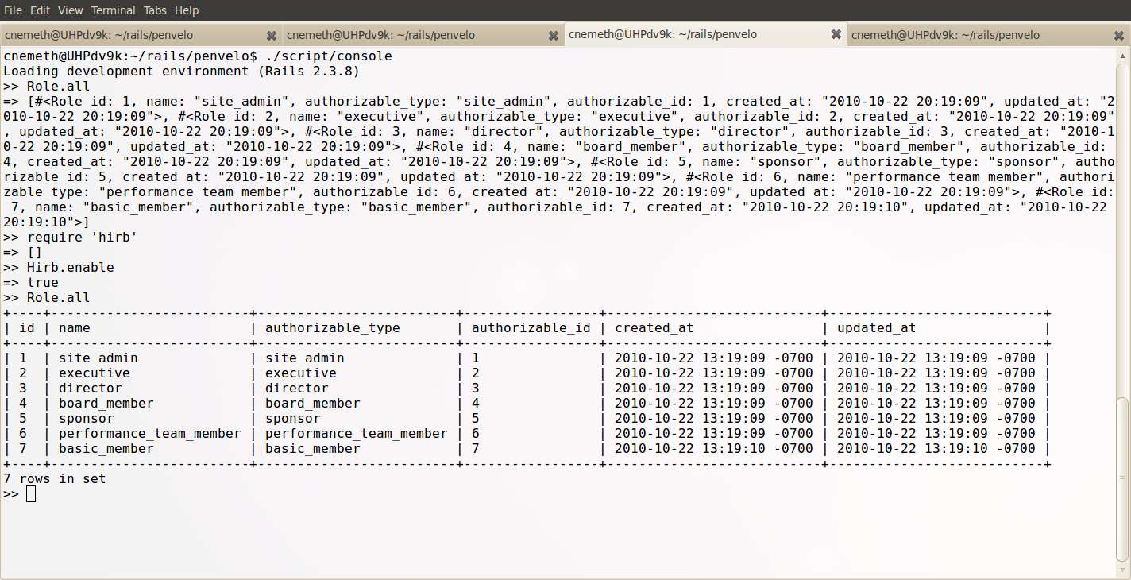

Figure : The interactive Rails console.

Figure 7 above shows console contains the interactive Rails console where the developer can interact with the application and test code. The output shown produced by

>> Role.all

is the content of the roles table in MySQL database. The first time we see the output in its raw format produced by the console. The second time, the nicely formatted table is produced by the Hirb plugin available from Github.com.

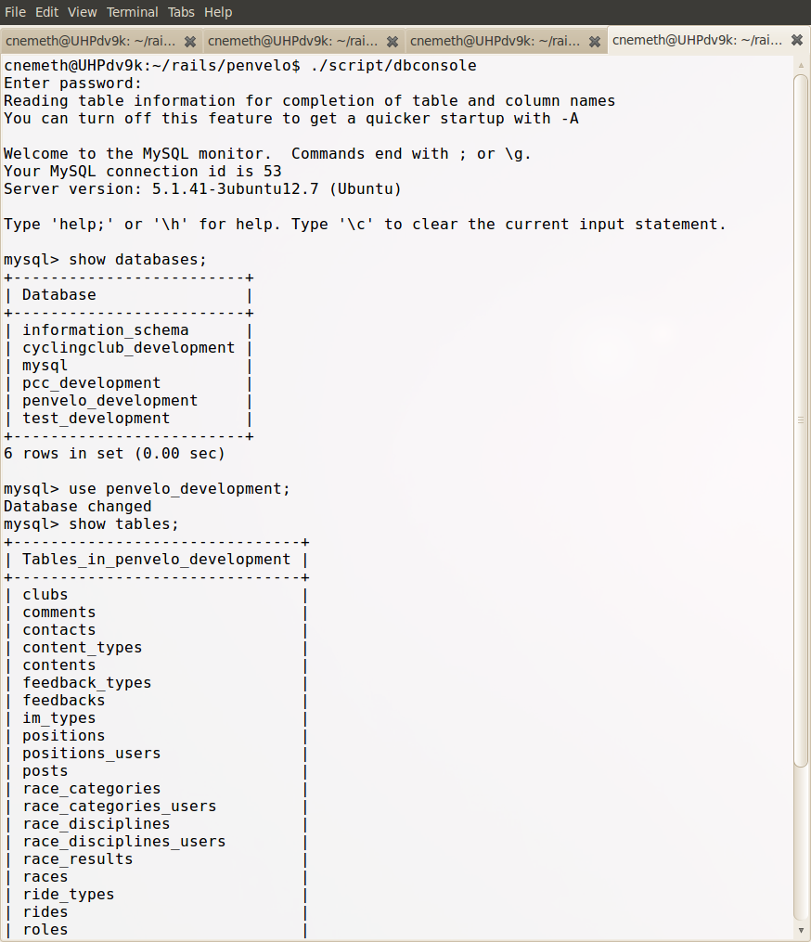

Figure : The database console

Figure 8 above shows the interactive database console. Again, in this console we can interact with the database. Of course there are graphical tools to manage and query databases. However, the db console is fast and it is always available.

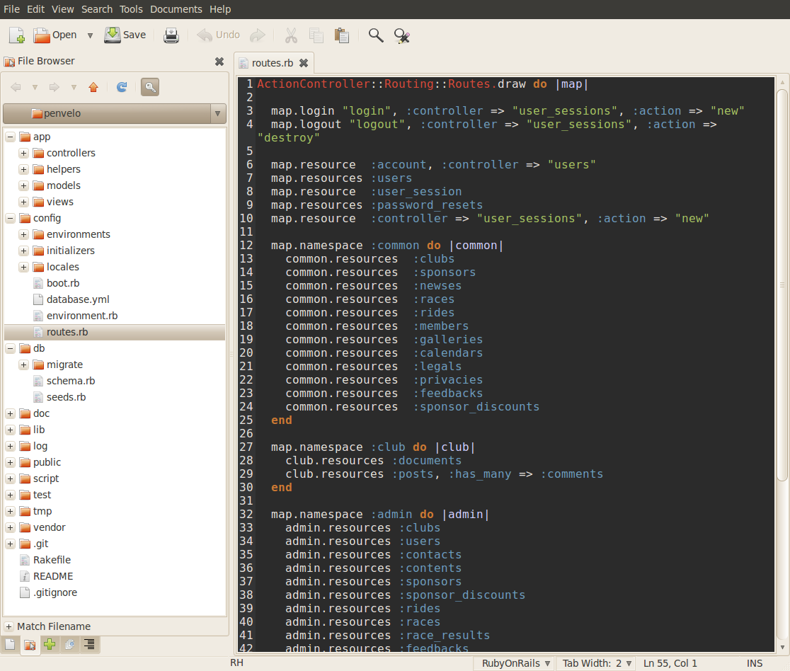

Figure : The GEdit text editor

Figure 9 above shows the GEdit text editor with the GMate plugin providing useful functions like code snippet extraction and syntax highlighting (Railscasts improved color scheme). The left window pane contains the Penvelo application tree as generated by Rails, and the edit window on the right has the routes.rb file open for editing. (The .rb file extension stands for Ruby.) Other good text editor choices for Rails development on Linux include Kate (KDE Advanced Text Editor), Emacs and Vim.

## Code Repository

The project repository was established using a free public account on Github.com, which is a source code hosting and collaborative development web site for software projects specializing in the Git source control system. Github offers both free and commercial accounts. The free accounts are great for projects with limited resources, such as this one. The URL of the repository is <http://github.com/cnemeth/pvonrails> and can be access, cloned or forked by anyone.

Github is based on the open-source distributed version control system, Git [31], developed by Linus Torvalds [4] and is designed to handle all kinds of software project. For example, the Linux kernel project source uses the Git version control system.

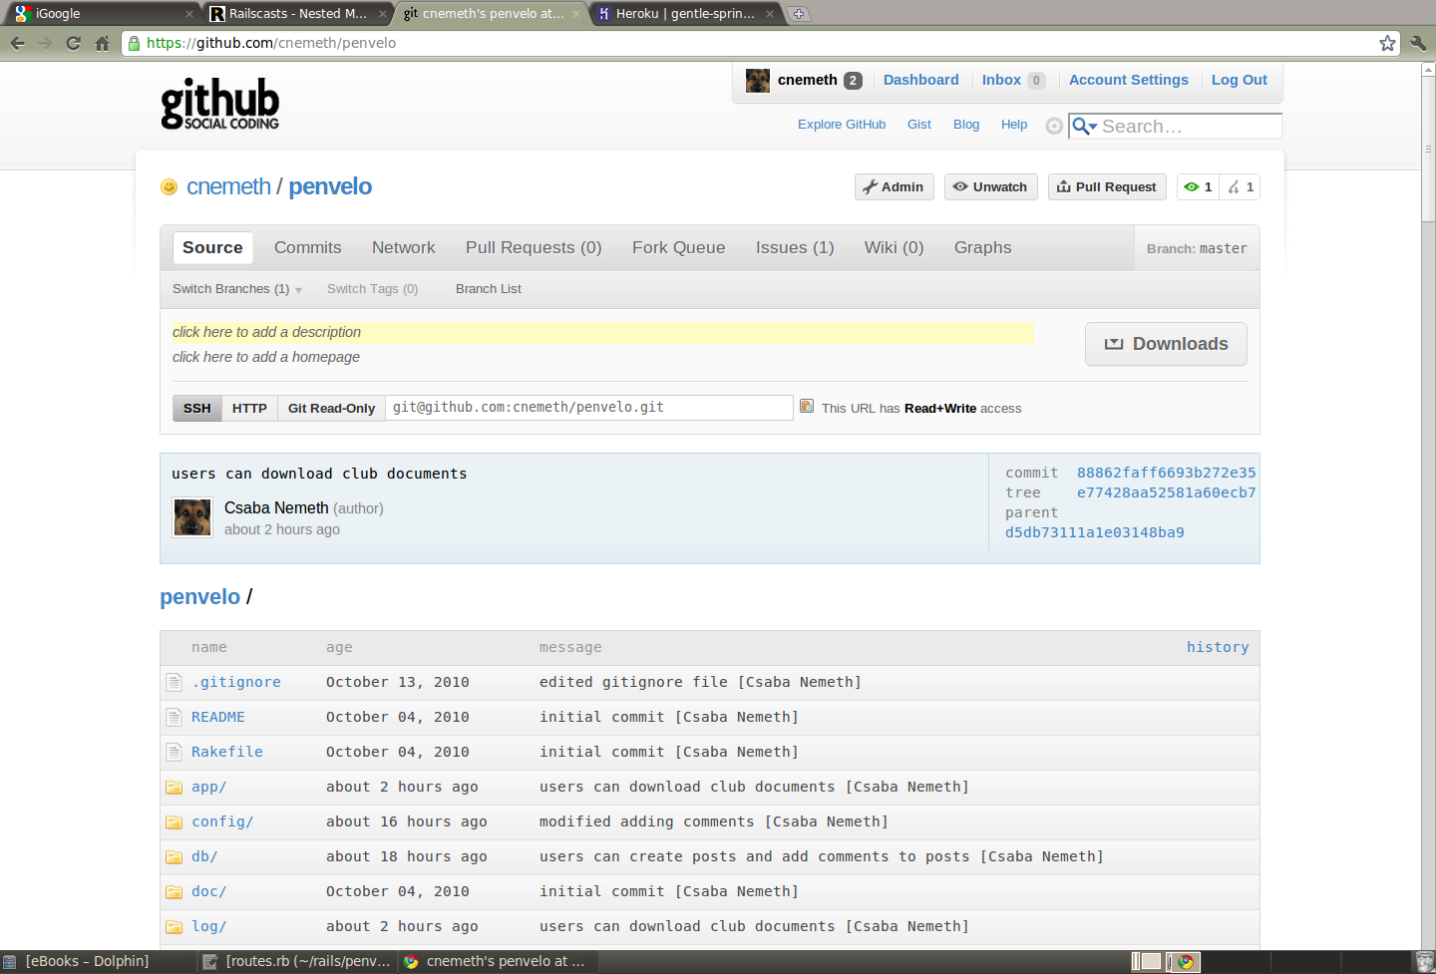

Figure : The Penvelo project's Github repository

## Website Hosting

The project test website is hosted on a free account on Heroku.com. Heroku is an Internet Service Provider (ISP) specializing in hosting Rails applications. It offers free, as well as, commercial accounts. The free accounts are great for development and testing for which is used currently. Heroku is certainly a possibility for hosting the production site; however, the decision is up to the club leadership. Other Rails hosting companies are EngineYard ([http://www.engineyard.com](http://www.engineyard.com/)), SliceHost (<http://www.slicehost.com/>), BlueHost (<http://www.bluehost.com/>), et al.

The URL of the test website is <http://pvonrails.heroku.com/>. The advantage of hosting the test website on Heroku is the ease of setup and minimal administration requirements. In addition, Heroku uses the Git version control system, which means that—after installing the heroku gem on the local development system--it takes a simple push command to update the project on Heroku from my local Git repository. (Note: At the writing of this report the Heroku site isn’t fully functional yet.) Figure 11 and Figure 12 show screenshots of the project summary page and the application running on Heroku.com, respectively.

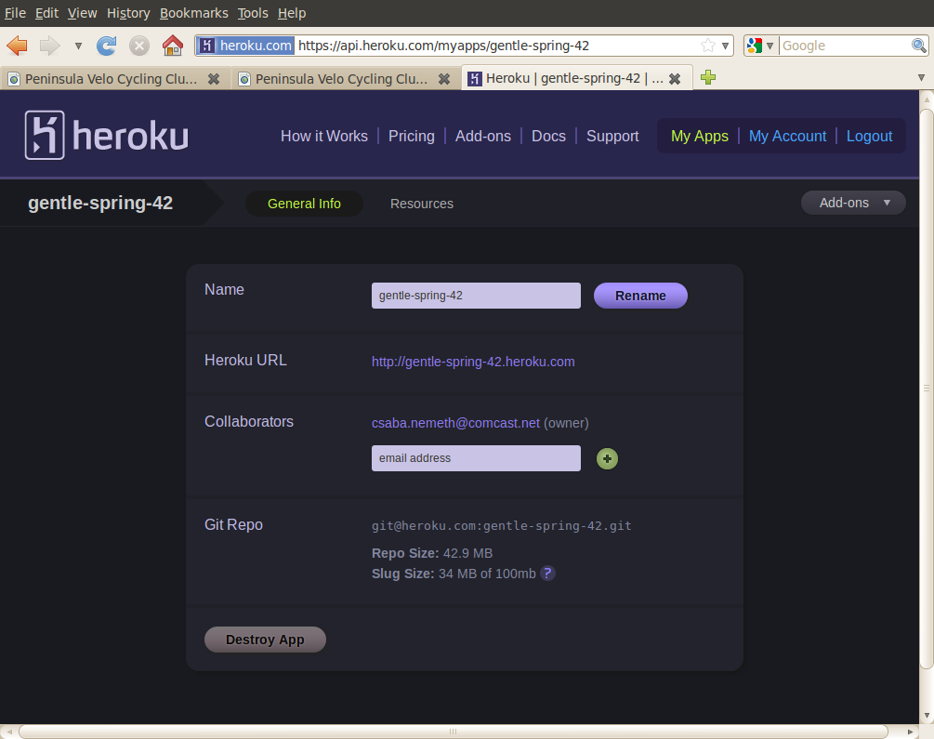

Figure : The Heroku project page

Figure 11 above shows the summary page for the Penvelo project on Heroku. When the application is first created on Heroku, it gets a randomly generated name assigned to it, in this case, gentle.spring-42. On free accounts, the application is public; that is, it can be access by anyone thought the URL http:/ gentle.spring-42.heroku.com/ as shown in Figure 12. If desired, application can be renamed to a more meaningful name; however, for now, the random name helps keep the application out of the public domain.

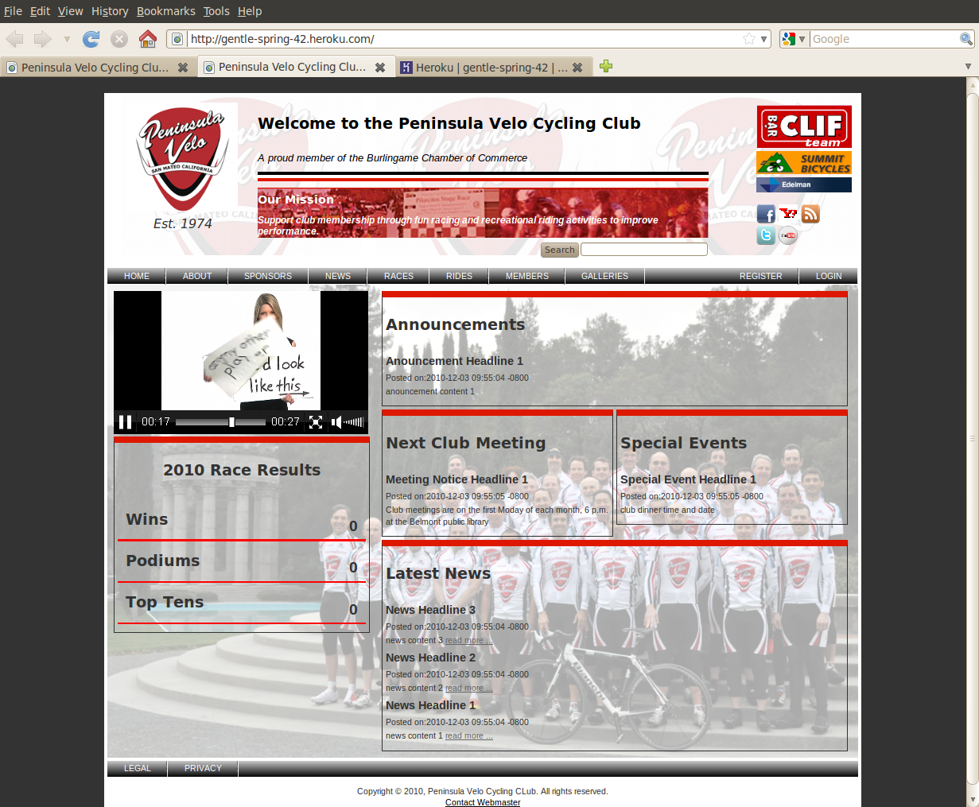

Figure 12: The Penvelo application running on Heroku.com

## Deliverables and Timing

Table : Project deliverable and timing

| Deliverable | Due Date | Mile Stone(s) |
| --- | --- | --- |
| Project Proposal (This report) | 18 January 2010 | Submit proposal |
| Project Progress Reports | January – November, 2010 | Submit progress reports periodically |
| Final report and Presentation, and Project demo | 20 December, 2010 | Submit documentation and demo |

## Risk Mangement

The two major risks associated with Rails projects are 1) hosting risk and 2) knowledge risk. The mitigation of both of these risks is ongoing.

### Hosting Risk

Finding a suitable hosting site can be an issue because Rails is still a relatively new web development framework and many ISPs provide very little support or none at all for setting up and running Rails applications on their servers. As of the writing of this report, the Penvelo application has been deployed to the Heroku site but it’s isn’t fully operational yet.

### Knowledge Risk

The knowledge risk was obvious from the outset since one of the reasons I started this project was to learn Rails and Ruby. Since I started out with practically zero knowledge about either Ruby or Rails, I was facing a very steep learning curve. This has been somewhat mitigated by the availability of great Rails web tutorials available on Railscasts.com [32] and Ruby and Rails books available from the Pragmatic Programmers [11]. And even though it is clear that it is not possible to become a full fledged expert in either Ruby or Rails during the course of a single project, I do feel I have learned a lot and was able to create a functioning application with web 2.0 features like playing multimedia, Google maps, etc.

## Feasibility

No monetary outlays or investment in software or infrastructure was required for this project--only time and effort. The project utilized only free and open-source software—Ubuntu Linux OS, Ruby, Rails, Rails gems and plugins, Mongrel webserver, MySQL RDBMS, GEdit text editor with the GMate plugin, Firefox web browser—and freely available resources like free accounts on Github.com for code repository and Heroku.com for hosting, and freely available tutorials on Railscasts.com for learning and other numerous sites for searching for solutions to problems.

Furthermore, there was no monetary compensation for the work or any hard deadlines imposed on the project. The new website is not a “necessity” but a “nice to have” for the operation of the club and was “commissioned” on a strictly volunteer basis with no compensation other than “bragging rights”. Hence, this project is not affected by deadlines and technological and budgetary constraints as much as a commercial project would be. Also, I was given a clean slate for the design and selection of the technologies, which, for me, was one of the attractive features of this project.

The new website will make a significant improvement to the club’s operation and to the quality of experience of the membership. Currently, the club has online presence on Yahoo Groups and Face Book, and most of the communication, outside the monthly club meetings, takes place through email. The new website provides significant improvement over this setup. For example, an obvious improvement is the ability to perform administrative functions through the web interface, e.g, registering new members online. Another significant advantage will be the consolidation of online activities in a single place resulting in a reduction in email traffic. For example, currently all racers file race report via email, which generates significant email traffic for all club members, including non-racers who might not be interested in the race reports. When the new web site is in operation, racers will be able to file race reports online blog-style, including restricting access to them since they sometimes contain confidential information. Another improvement is that racers will be able to link their race reports to Google maps, and link in video clips of races recorded using onboard cameras.

The purpose of the project was not to compete against other club web websites but to build a functional show case for the club. Most non-profit organizations of this type have limited financial and other resources and their website tend to be very basic created and maintained by volunteers (links to cycling club websites can be found at the USA Cycling website <http://www.usacycling.org/clubs/>). Therefore, the quality and technical features of the websites are greatly dependent on the technical expertise and the time the volunteers can devote building and maintaining the sites.

# Application Design

Since this project followed a quasi agile development method, there was no extensive upfront design work done but rather, it was more of an evolutionary process. As mentioned before, this sort of evolutionary process is highly suitable for the Rails philosophy of application development—just like a tree germinating from a seed, a Rails application starts small and grows from there. The three figures below—Figure 13, Figure 14 and Figure 15—define the application. Figure 13 is a high-level conceptual representation of the system, figure 14 is a map of the web site, and figure 15 is the representation of the current database schema, which also serves as the object-relational model (ORM) for the application. Figure 13 hasn’t changed at all. Figure 14 went through some minor changes but is essentially very similar to the initial design. Figure 15 however, went through major changes throughout the development process, which underlines the fact that Rails applications are highly database-centric.

## High-level Application Architecture

In Figure 13, the most apparent features of the Penvelo application are the multi-level access control and ease of administration through the web interface.

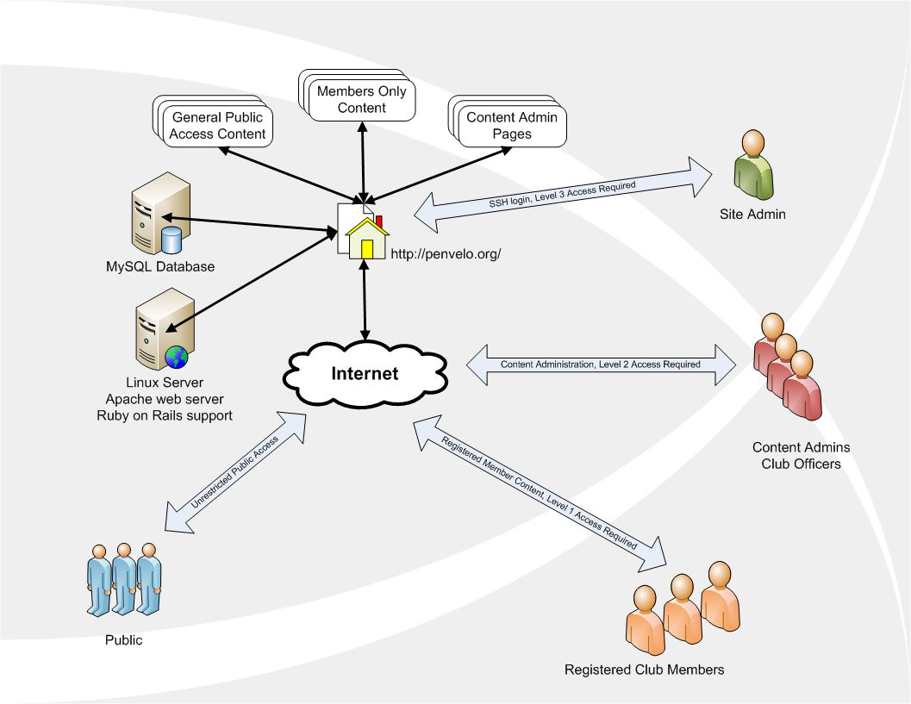

Figure : High-level design of the Penvelo website application

## Web site Structure

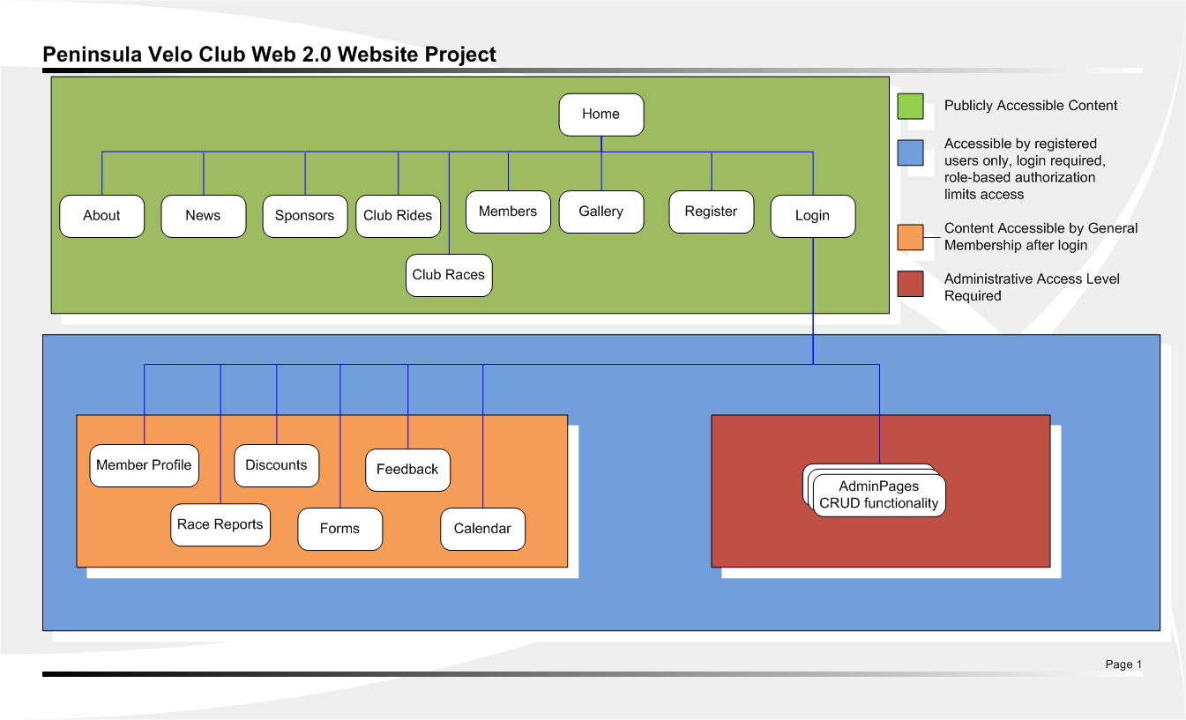

Figure : The Penvelo website structure

## Page Layout

$ … explain the partial views and how they are linked together …

### Layout Design of Public Pages

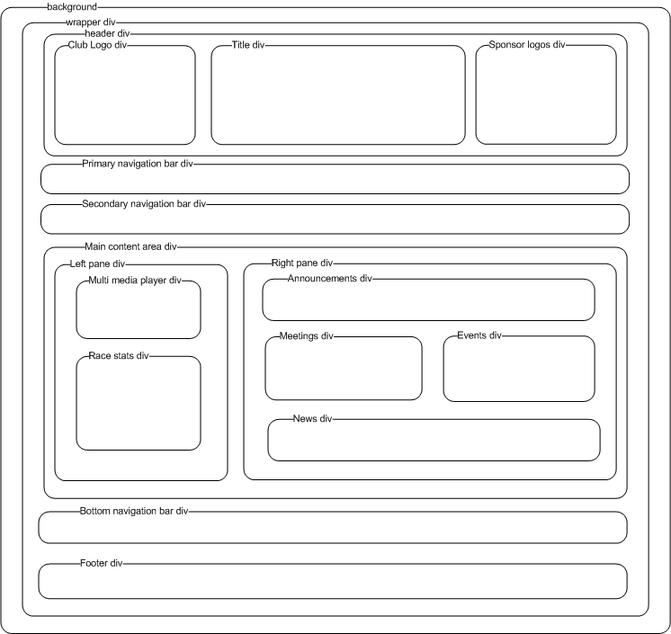

Figure : Public home page layout design

### Layout Design of Admin Pages

$ …

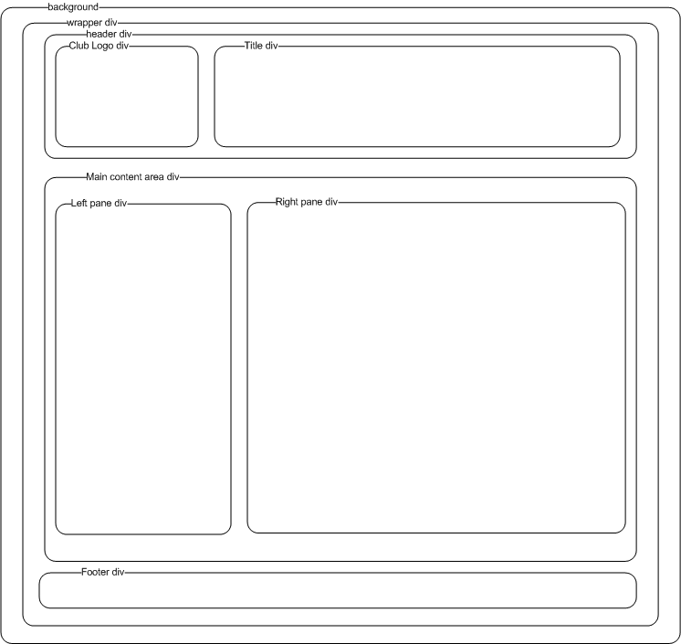

Figure " Admin home page layout design

### View Partials

$ … explain the partial views and how they are linked together … add a figure showing view partial hierarchy …

## Database Schema and Class Diagrams

$ …

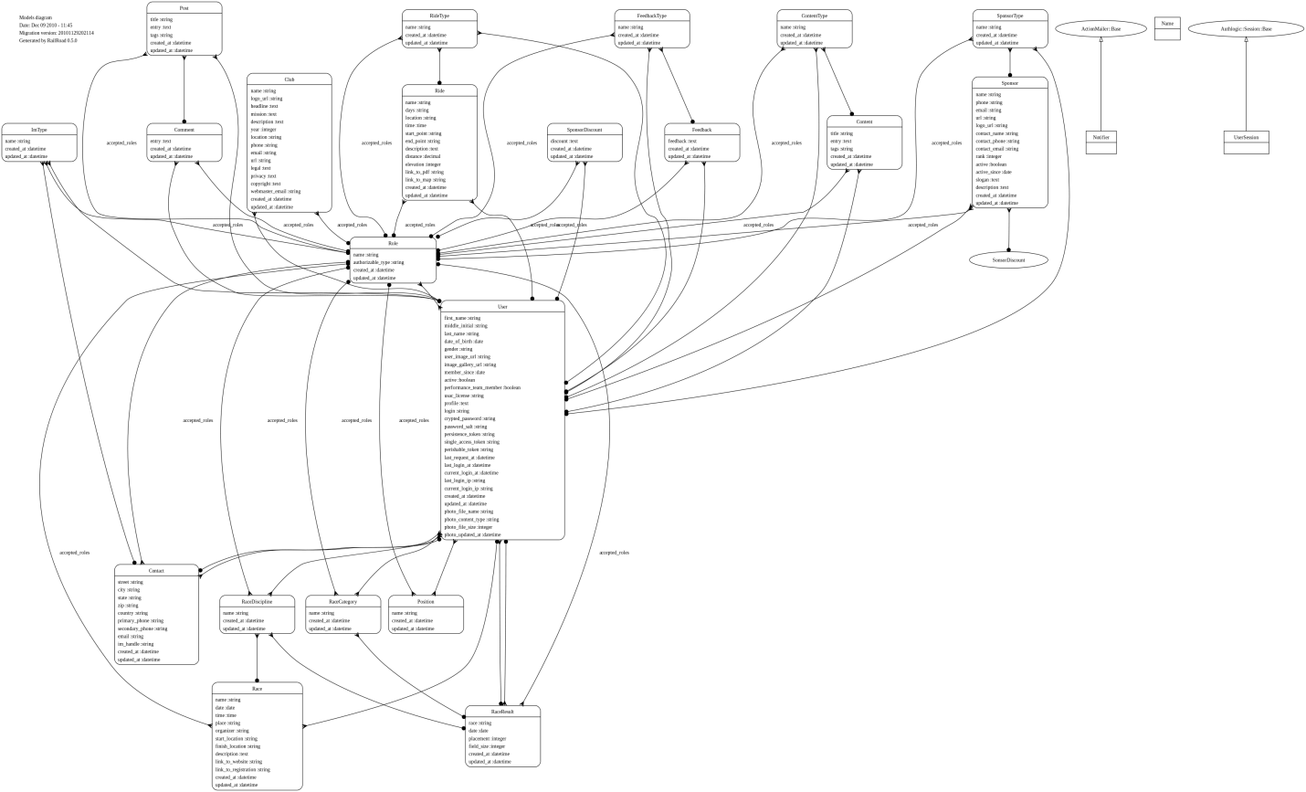

Figure : ORM class diagram

$ …

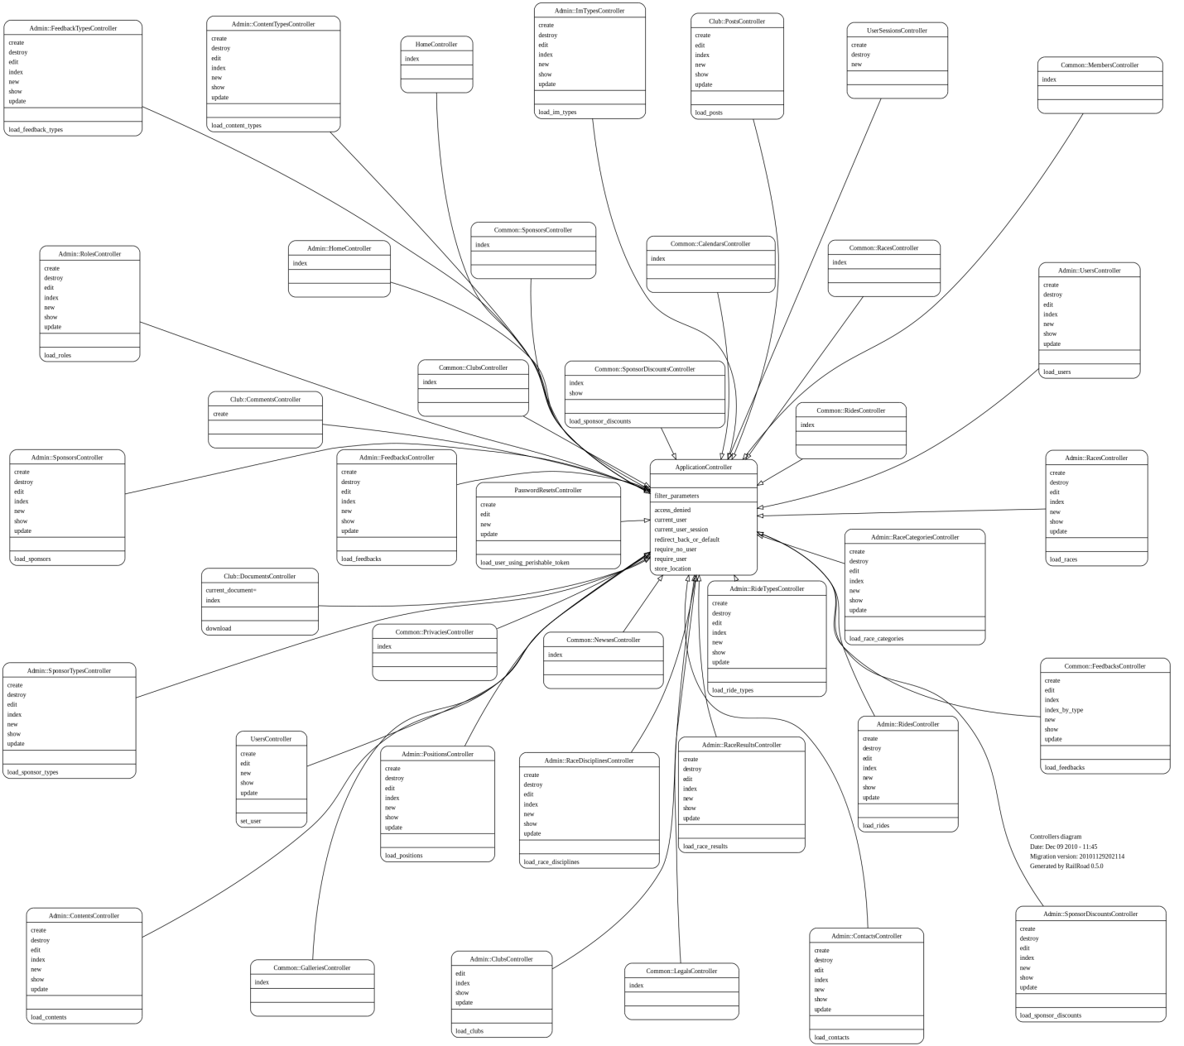

Figure : Controller class diagram

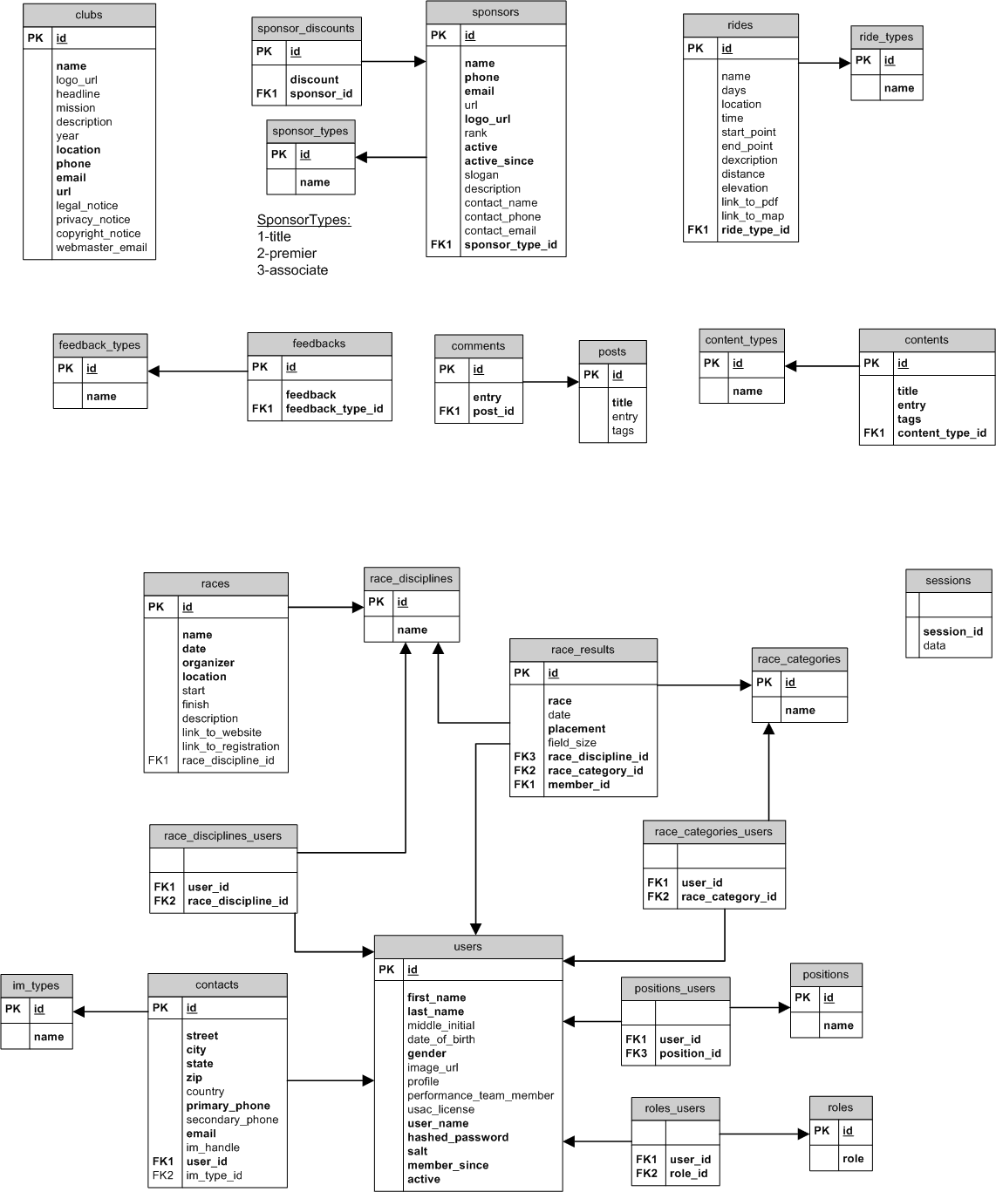

Figure : The database schema for the penvelo.org web 2.0 website

… has_and_belongs_to_many (habtm)

# Implementation Details

## Ruby Gems and Plugin Modules

$ … in this section explain all the extende functionality provided by the third-party gems and plugins used in the application …

### User Authentication

$ … authlogic…

### Role-Based Authorization

$ … acl9 …

### Form Handling and ValidatioN

$ … formtastic and validation_reflection and will_paginate …

### File Upload

$ … paperclip

### Searching

$ … search logic

Multi-Media Player

$ … jw player

### Miscellaneous

The Ruby gem annotate [45] was used to annotate model files. annotate reads the database migrations and writes the schema information for the corresponding model into the model’s .rb file contained in the application’s /app/models directory. This is a nice convenience feature that assists the developers and maintainers of the application. An example of the annotation produced by annotate is shown below for the *Content* model.

# == Schema Information

#

# Table name: contents

#

# id :integer(4) not null, primary key

# title :string(255) not null

# entry :text

# tags :string(255)

# content_type_id :integer(4)

# created_at :datetime

# updated_at :datetime

#

### RSS Feed

The RSS feed implementation was based on episode #87. XML implementation … builder … /app/views/layouts/_sws_links.html.erb…

<%= link_to(image_tag("rssfeed.png", :size => "30x30"), common_newses_url(:rss)) %>

…/app/views/common/newses/index.rss.builder …

xml.instruct! :xml, :version => "1.0"

xml.rss :version => "2.0" do

xml.channel do

xml.title "News"

xml.description "Latest Penvelo News"

xml.link common_newses_url(:rss)

for news in @newses

xml.item do

xml.title news.title

xml.description news.entry

xml.pubDate news.created_at.to_s(:rfc822)

xml.link common_newse_url(news, :rss)

xml.guid common_newse_url(news, :rss)

end

end

end

end

# Testing

$ … testing?... what testing?! … test are built into rails, highly suitable for pair programming

# Future Development

$... code factoring, adding new features

# Conclusion

$ …heck of learning experience

# Definitions, Acronyms and Abbreviations

Table Abbreviations and acronyms

|  |  |
| --- | --- |
| Abbreviation/Acronym | Definition |
| ANSI | American National Standards Institute |
| CSS | Cascading Style Sheet |
| CRUD | Create, Read, Update, Delete |
| ER | Entity Relation |
| ERb | eRuby (Embedded Ruby) Processor written in the Ruby language |
| GIMP | GNU Image manipulation Program |
| Git | Free, open-source, distributed version control system |
| GUI | Graphical User Interface |
| HABTM | Has And Belongs To Many |
| HTML | HyperText Markup Language |
| IDE | Integrated Development Environment |
| ISO | International Standards Organization |
| ISP | Internet Service Provider |
| MVC | Model View Controller software design pattern |
| OOD | Object Oriented Design |
| OOP | Object Oriented Programming |
| ORM | Object Relational Models |
| OS | Open Source/Operating System |
| PV | Peninsula Velo Cycling Club (a.k.a. Penvelo) |
| RDBMS | Relational Database Management System |
| RoR | Ruby on Rails (web development framework) |
| RSS | Really Simple Syndication (web feed format used for publishing frequently updated online content like news) |
| RUP | Rational Unified Process |
| SDD | Software Design Description |
| SDK | Software Development Kit |
| SFTP | Secure File Transfer Protocol |
| SPMP | Software Project management Plan |
| SRS | Software Requirements Specification |
| SSH | Secure Shell (for Linux server login) |
| STD | Software Test Documentation |
| SVN | Subversion (an open-source version control system) |
| UMD | University of Michigan—Dearborn |
| VLT | Virtual Learning Tool |
| VOIP | Voice Over IP |
| W3C | World Wide Web Consortium |
| XML | eXtensible Markup Language |
| XHTML | eXtensible HyperText Markup Language |
| XP | eXtreme Programming (one of the agile software development methods) |

# References

1. W3C, <http://www.w3.org/>
2. Yukihiro Matsumoto, <http://en.wikipedia.org/wiki/Yukihiro_Matsumoto>
3. David H. Hansson, <http://en.wikipedia.org/wiki/David_Heinemeier_Hansson>
4. Linus Torvalds, <http://en.wikipedia.org/wiki/Linus_Torvalds>
5. Wikipedia, Agile Software Development, <http://en.wikipedia.org/wiki/Agile_software_development>
6. Ruby language web page, <http://www.ruby-lang.org/en/>
7. Ruby on Rails web page, <http://rubyonrails.org/>
8. Rails API version 2.3.8, <http://api.rubyonrails.org/v2.3.8/>
9. Ruby Core Reference, <http://www.ruby-doc.org/core/>
10. RubyGems.org <http://rubygems.org/>
11. The Pragmatic Bookshelf, http://www.pragprog.com/
12. Ian Sommerville: “Software Engineering”, 8th ed., Addison-Wesley, 2007
13. Sam Ruby, Dave Thomas, David Heinemeier Hansson: “Agile Web Development with Rails”, 3rd ed., The Pragmatic Programmers, 2009
14. Ezra Zygmuntovicz, Bruce Tate, Clinton Begin: “Deploying Rails Applications, A Step-by-Step Guide”, The Pragmatic Programmers, 2008
15. Yukihiro Matsumoto: “Ruby in a Nutshell”, 1st ed., O’Reilly, 2002
16. Dave Thomas: “Programming Ruby”, 2nd ed., The Pragmatic Programmers, 2005
17. Chuck Musciano, Bill Kennedy: “HTML & XHTML, The Definitive Guide”, 6th ed., O’Reilly, 2007
18. Eric A. Meyer: “CSS, The Definitive Guide”, 3rd ed., O’Reilly, 2007
19. David Flanagan: JavaScript, The Definitive Guide”, 5th ed., O’Reilly, 2006
20. David Griffiths: “Head First Rails”, O’Reilly, 2009
21. Alistair Cockburn: “Writing Effective Use Cases”, Addison-Wesley, 2001
22. SHA1 Encryption, <http://en.wikipedia.org/wiki/SHA_hash_functions>
23. MySQL home page <http://www.mysql.com/>
24. Mike Clark, et al.: “Advanced Rails Recipes”, The Pragmatic Programmers, 2008
25. Sam Ruby, Dave Thomas, David Heinemeier Hansson: “Agile Web Development with Rails”, 4th ed. beta 4, The Pragmatic Programmers, May 2010
26. The Apache Software Foundation, <http://www.apache.org/>
27. Phusion Passenger, <http://www.modrails.com/>
28. Capistrano, <http://www.capify.org/index.php/Capistrano>
29. Git, <http://git-scm.com/>
30. Free Ruby on Rails screencasts by Ryan Bates, <http://railscasts.com/>, episodes 87, 184, 185, 196, 197, 217, et al.
31. Rational Unified Process (RUP) <http://www-01.ibm.com/software/awdtools/rup/>, <http://en.wikipedia.org/wiki/IBM_Rational_Unified_Process>
32. Dave Thomas, PragDave, <http://pragdave.pragprog.com/>
33. RailRoad class diagram generator <http://railroad.rubyforge.org/>
34. GIMP (GNU Image Manipulation Program), <http://www.gimp.org/>
35. RDoc - Ruby Documentation System, <http://rdoc.sourceforge.net/doc/index.html>
36. recordMyDesktop, Desktop session recorder for GNU/Linux, <http://recordmydesktop.sourceforge.net/about.php>
37. Google Maps API web page, <http://code.google.com/apis/maps/signup.html>
38. Authlogic on Github, <https://github.com/binarylogic/authlogic>
39. Searchlogic on Github, <https://github.com/binarylogic/searchlogic>
40. Acl9 on Github, <https://github.com/be9/acl9>
41. Formtastic on Github, <https://github.com/justinfrench/formtastic>
42. Validation_reflection on Github, <https://github.com/redinger/validation_reflection>
43. Paperclip on Github, <https://github.com/thoughtbot/paperclip>
44. JW Player, <http://www.longtailvideo.com>
45. Annotate, <https://github.com/ctran/annotate_models>

# APPENDIX A: WEBSITE STRUCTURE DESCRIPTION

## NON-ADMIN LAYOUT

These elements are common to all pages.

* Header
  + Incorporating
    - club logo—also serves as a link to the public home page
    - club slogan and vision statement
    - important sponsor logos
    - icon links to social websites and rss feed
  + search users by last name
* Dynamically loaded menu bars
  + Public access
    - Home, About, Sponsors, News, Races, Rides, Members, Gallery, Login, Register
  + Registered user access
    - Posts, Sponsor Discounts, Documents, Calendar, My Profile, logout
  + Administrator access
    - Admin
* Side bar
  + Media player
  + Race results summary
* Main content area
  + Content varies according to page context, see individual page details below.
* Bottom bar menu
  + Legal notice
  + Privacy notice
  + Feedback page
* Footer
  + Copyright notice
  + Email link to Webmaster

## ADMIN LAYOUT

These elements are common to all admin pages.

* Header
  + Title
  + Club logo—also serves as a link to the public home page
  + Search users by last name
* Side bar
  + Admin menu
* Main content area
  + Content varies according to page context.
* Footer
  + Copyright notice
  + Email link to Webmaster

PUBLIC ACCESS CONTENT   
Open to the general public, no registration or login required to access content on these pages.

### INDIVIDUAL PAGE DETAILS—MAIN CONTENT AREA

HOME

* Summary of current news headlines, announcements, and events

ABOUT

* Mission statement
* History
* Club officers

SPONSORS

* Benefits of becoming a penvelo sponsor
* List of current sponsors
  + Name of Business
  + Club liaison
  + Short descriptions of the type of business
  + Benefits provided by sponsor
  + Website link

NEWS

* News events related to cycling and to the club membership in general

RACES

* Details of club-sponsored race events

NEWS

* Details of weekly club rides

MEMBER PROFILES

* Picture
* Name
* Place of Residence
* Type of riding
* Member since
* Email link
* Link to profile, blog and member’s Facebook account, flick or picasa web album, etc.

GALLERY

* Photo galleries of races, events, etc. (not implemented in this release)

LOGIN

* User name
* Password
* Employs role-based authentication

LEGAL

* Legal notice to website users

PRIVACY

* Privacy notice to website users

RISTRICTED ACCESS CONTENT—Level 1   
Club member level registration/login required to access this content.  
MEMBER PROFILE

* Registered members can create, view, edit and delete their own profiles
  + picture
  + name
  + contact info
  + type of riding they do
  + bikes they own
  + likes and dislikes
  + setup and administer blog account
  + add links to their external web resources (e.g., facebook, web album, blogs, etc.)

SPONSOR DISCOUNTS

* Describe sponsor-provided discounts to users
* Provide links, contact info to obtain discounts

DOCUMENTS AND FORMS

* Club Bylaws
* Membership renewal form
* Performance Team application
* Uniform crash replacement policy
* Entry fee reimbursement policy
* Etc.

CALENDAR

* Upcoming Events (not implemented in this release)

FEEDBACK

* Website users can prost messages to the site regarding usage, bugs, etc.

RISTRICTED ACCESS CONTENT—Level 2   
Admin level registration/login required to access this content. Users with admin level have full CRUD (Create, Read, Update, Delete) access to the entire database content. Each menu item links to a table in the database

GENERAL CLUB INFO AND POLICIES

* Create, view, update and delete information in the clubs table of the database

MEMBERS

* Create, view, update and delete information in the users table of the database
* Create, view, update and delete information in the contacts table of the database

NEWS AND EVENTS

* Create, view, update and delete information in the contents table of the database

SPONSORS

* Create, view, update and delete information in the sponsors table of the database
* Create, view, update and delete information in the sponsor_discounts table of the database

RACES AND RIDES

* Create, view, update and delete information in the club_races table of the database
* Create, view, update and delete information in the club_rides table of the database
* Create, view, update and delete information in the race_results table of the database

FEEDBACK

* Create, view, update and delete information in the feedbacks table of the database

MISCELLANEOUS

* Create, view, update and delete information in the roles table of the database
* Create, view, update and delete information in the positions table of the database
* Create, view, update and delete information in the im_types table of the database
* Create, view, update and delete information in the content_types table of the database
* Create, view, update and delete information in the sponsor_types table of the database
* Create, view, update and delete information in the ride_types table of the database
* Create, view, update and delete information in the feedback_types table of the database
* Create, view, update and delete information in the race_categories table of the database
* Create, view, update and delete information in the race_disciplines table of the database

# Appendix B: Main Use cases

This section contains the main use cases for the Penvelo application. The use cases are divided into three major categories: general use cases, use cases that apply to registered users and use cases that apply to registered users with administrator rights. The use cases follow the outline of the Rational Unified Process (RUP) [33][21] use case template as shown below.

Use Case Name

1. Brief description
   1. Actors
   2. Triggers
2. Flow of Events
   1. Basic flow
   2. Alternative flows
      1. Condition 1
      2. Condition 2
      3. …
      4. Condition *n*
3. Special Requirements
   1. Platform
   2. …
4. Preconditions
5. Postconditions
   1. Success postcondition(s) [success guarantee]
   2. Failure postcondition(s) [minimal guarantee]
6. Extension Points

## Notes and Assumptions

‘System’ refers to the

* Rails framework comprising
* the various Ruby gems and plugins that extend the Rails framework with additional functionality,
  + authlogic—user authentication
  + acl9—role-based user authorization
  + formtactic—handling form layout and form input
  + validation_reflection—specifying required fields and validating fields in forms
  + paperclip—handling file uploads
  + searchlogic—search function
  + will_paginate—list pagination
  + jw-player—multi-media player
* the web server, and
* the RDBMS, in this case the MySQL server.

For all use cases, it is assumed that the user has an active internet connection and is using a modern web browser like FireFox version 3.6 or similar.

## General Use Cases

### Use Case 1: Processing Requests and Responses—System Level, White Box

1. Brief description

This use case describes internal mechanism that Rails applications use to process incoming requests and outgoing responses. Figure 3 (page 11) can serve as the use case diagram for this use case.

* 1. Actors
     1. User browser (primary)
     2. System (secondary)
        1. Request routing subsystem
        2. Controller
        3. Model
        4. ERb templating system
        5. Web server
        6. Database server
  2. Triggers
     1. This operation is invoked implicitly when the user’s browser sends a request to the web server

1. Flow of Events
   1. Basic flow
      1. User’s browser sends a request to the web server which forwards the request to the application’s routing sub system
      2. Router parses the incoming request for a particular controller-action (action is a method in Rails terminology) pair and routes the request to the identified action of the controller.
      3. The controller may invoke the pertinent model (ORM) to retrieve data from the database, and any other actions necessary to fulfill the request.
      4. As the last step, the controller action prepares the output for the particular view, which gets rendered by the eRuby processor. The resulting output is usually HTML but it could be XML or any other format also.

[Notes on ERb:

ERb processes templates, which have Ruby code embedded in them. Erb templates have a file name ending in .erb. For example, index.html.erb is template containing html and embedded Ruby code and defines the index page view of something (e.g., the listing of all users in the users database table).

The Ruby code is embedded in the template either as an expression or a scriptlet. An expression is a single line of code as shown below in the example

<p><%=h user.name %></p>

The above expression gets evaluated by the processor and its value—in this case the user’s name—gets back-substituted as a string into the <p> html tag. (h is just a Rails helper method that escapes characters in the resulting string that may mess up the html and also helps prevent SQL injection attacks. )

A scriptlet is a block of code that gets executed and looks like below

<% @posts.each do |post| %>

<tr class="<%= cycle('list-line-odd', 'list-line-even') %>">

<td><%=h post.title %></td>

<td><%=h post.comments.length %></td>

<td><%=h post.updated_at.to_s(:rfc822) %></td>

</tr>

<% end %>

The above Ruby code block is an excerpt taken from the index.html.erb file of the index page view of Posts simply lists the title, number of comments, and the date of each posting in a table row.]

* + 1. The web server returns the output to the user’s browser.
  1. Alternative flows
     1. None

1. Special Requirements
   1. Rails web development framework version 2.3.x
2. Preconditions
   1. Web server received a request from the user’s web browser
3. Postconditions
   1. Success postcondition(s) [success guarantee]
      1. System has returned a response to the user and is waiting for user
   2. Failure postcondition(s) [minimal guarantee]
      1. System is waiting for user. The following states are possible
         1. HTML 400 Bad Request
         2. HTML403 Forbidden—most likely due to insufficient access right
         3. HTML 404 Page Not Found—most likely due to the Router could not determine how to route request
         4. HTML 422Change you wanted was rejected—most likely due to insufficient access right
         5. HTML500 Internal Server Error—something went wrong
         6. HTML 503 Service unavailable
4. Extension Points
   1. None

### Use Case: Authenticate User—System-level, White box

$ …

### Use Case: Authenticate User—System-level, White Box

$ …

### Use Case 2: Login—System level, black box

1. Brief description

This use describes the login process for the system. A registered user logs onto the website with login name and password, after which, the user is able to access restricted content, post messages and edit his/her user profile.

* 1. Actors
     1. User (primary)
     2. System (secondary)
  2. Triggers
     1. User explicitly invokes this operation by clicking on the ‘Login’ button on the main menu bar

1. Flow of Events

The use case begins when the user navigates to the penvelo.org home page using a web browser and clicks the ‘login’ button on the main menu bar. (Insert figure reference here for screen shot of home page.)

* 1. Basic flow
     1. Login
        1. User clicks the ‘login’ button on main menu bar
        2. The system displays the login form
        3. User enters the login name and password into the input boxes provided by the form—may or may not click the ‘Remember me’ check box—and clicks the ‘Submit’ button on the form
        4. The system—with the help of the authentication and role-based authorization sub system and the database management system—verifies the user’s credentials, logs in the user and displays the application’s home page with a ‘Login successful!’ message on the top of the main content area
  2. Alternative flows
     1. Cancel login
        1. User does not click on ‘Submit’ button but navigates to a different page instead

1. Special Requirements
   1. The following Ruby gems and/or plugins must be installed on the system
      1. authlogic
      2. acl9
2. Preconditions
   1. The user has navigated to the Penvelo application and has an account on the system
3. Postconditions
   1. Success postcondition(s) [success gurantee]
      1. User is logged in and the system is waiting for further user action
   2. Failure postcondition(s) [minimal guarantee]
      1. User is not logged in. An error message is displayed at the top of the login form and the text input box containing the error is highlighted in red. System is waiting for further action from user.
4. Extension Points
   1. None

### Use Case 3: Logout—System level, black box

1. Brief description

This use case describes the logout process of the system.

* 1. Actors
     1. User(primary)
     2. System (secondary)
  2. Triggers
     1. User explicitly invokes this action by clicking on the ‘Logout’ button on the main menu bar

1. Flow of Events
   1. Basic flow
      1. User clicks “logout’ button on main menu bar
      2. Systems displays a confirmation dialog with ‘OK’ and Cancel” buttons and waits for user input
      3. User clicks the ‘OK’ button on the confirm dialog
      4. System destroys session for user and redirects user to application’s (public) home page (only main menu bar is displayed on top with buttons to public access content and ‘Register | Login’ buttons) where it displays “Logout successful!’ message at the top of the main content area of the page
   2. Alternative flows
      1. User cancels ‘Logout’ operation
         1. User clicks “Cancel’ button on confirmation dialog
         2. System removes confirmation dialog and stays on current page
2. Special Requirements
   1. The following Ruby gems and/or plugins must be installed on the system
      1. authlogic
      2. acl9
3. Preconditions
   1. User is logged in
4. Postconditions
   1. Success postcondition(s) [success guarantee]
      1. User has been logged out
      2. User session has been destroyed by system
      3. User is redirected to the application’s home page and system is waiting for further action from user
   2. Failure postcondition(s) [minimal guarantee]
      1. System is waiting for action from user
5. Extension Points
   1. None

### Use Case 4: Register User—System level, black box

1. Brief description

This use case describes the Register User process for the system, which is similar to Edit User Profile use case because they share the registration/edit form component.

* 1. Actors
     1. User (primary), must be a club member who does not have an account on the system
     2. System (secondary)
  2. Triggers
     1. User explicitly invokes this action by clicking on the ‘Register’ button on the main menu bar

1. Flow of Events
   1. Basic flow
      1. User clicks the ‘Register’ button on the main menu bar
      2. System displays blank registration form; required fields are marked by an asterisk
      3. User completes form and clicks ‘Submit’ button—at minimum all required fields must be completed
      4. System verifies that all required fields are completed and that fields contain correct data types and values and redirects user to the user profile page displaying the user’s (newly created) profile. An ‘Account for user user_name was successfully created!’ message is displayed at the top of the main content area.
   2. Alternative flows
      1. User may decide to upload a photo of him/herself, see Upload User Photo File use case
      2. User may not complete registration process by navigating to a different page
      3. Alternatively, user may ask admin to register/create profile for the user, see Manage Data use case
2. Special Requirements
   1. The following Ruby gems and/or plugins must be installed on the system
      1. authlogic
      2. acl9
      3. formtactic
      4. validation_reflection
      5. paperclip
3. Preconditions
   1. User must be a club member who does not have an account on the system
4. Postconditions
   1. Success postcondition(s) [success guarantee]
      1. User account has been created (i.e., user has been added to the users table of the database)
      2. User is logged into the system and a user session has been created
      3. System is waiting for further user action
   2. Failure postcondition(s) [minimal guarantee]
      1. User account has not been created and user is not logged in to the system
      2. System is waiting for further user action
5. Extension Points
   1. After user has been registered with the system, Admin must set user role (i.e., executive, director, etc., see Manage Data use case) in user’s profile. This user role will define user’s access level on the system. Before the user’s role is set, user has only basic privileges on the system.

### Use Case 5: Upload User Photo FIle—System level, Black Box

1. Brief description

This use case describes the Upload User Photo File use case. This use case is called from the Register User or Edit User Profile use cases.

* 1. Actors
     1. User(primary)
     2. System (secondary)
  2. Triggers
     1. User explicitly invokes operation in either the Register User or Edit User Profile use case

1. Flow of Events
   1. Basic flow
      1. In the registration form, user clicks the ‘Browse’ button next to the input box labeled ’User photo’
      2. System opens a ‘File browser’ dialog
      3. User browses for the file (on the local system), selects the desired file, and then clicks the ‘OK’ button of the file browser dialog.
      4. System loads file path and name in to the input box
   2. Alternative flows
      1. Instead of browsing for photo file, User types in the file path and name into input box manually
      2. User can cancel file upload by clicking the ‘Cancel’ button on the ‘File browse’ dialog, or delete the content of the ‘User photo’ input box manually.
2. Special Requirements
   1. The paperclip Ruby plugin must be installed to provide file upload functionality
3. Preconditions
   1. User is creating/editing his/her profile and explicitly invokes this operation
   2. File exists on user’s local system that can be uploaded
      1. File size requirement
         1. Must be less than 1 MB
      2. File type requirement
         1. Allowable file types are jpg, jpeg, gif and png
4. Postconditions
   1. Success postcondition(s) [success guarantee]
      1. File path and file name of user photo file is loaded in input box by system
   2. Failure postcondition(s) [minimal guarantee]
      1. System is waiting for user action. Possible states include
         1. Form data may still be valid
5. Extension Points
   1. None

### Use Case 6: Search for User by Last Name—System level, Black Box

1. Brief description

This use case describes the Search for User by Last Name use case.

* 1. Actors
     1. User(primary)
     2. System (secondary)
  2. Triggers
     1. User implicitly invokes this operation by clicking the ‘Search’ button next to the search input text box in the page header in both public and admin pages

1. Flow of Events
   1. Basic flow
      1. User types a last name (case insensitive) into the search text input box and clicks the search button
      2. System will return all user profiles that have a matching last name and displays them in a tabular format in the main content area of the page
   2. Alternative flows
      1. None
2. Special Requirements
   1. The searchlogic Ruby gem must be installed on the system to provide search functionality
3. Preconditions
   1. User’s browser has the Members page (public) or the Users page (admin) loaded
   2. User typed a search string into the search text box
4. Postconditions
   1. Success postcondition(s) [success guarantee]
      1. System has returned a set of matching user profiles (or none) and displayed them on the page and is waiting for further user action
   2. Failure postcondition(s) [minimal guarantee]
      1. System is waiting for user action
5. Extension Points
   1. None

## Registered User Use Cases

### Use Case 7: Edit User Profile—System level, black box

1. Brief description

This use case describes the Edit User Profile process, which is similar to the Register User use case because they share the registration/edit form component.

* 1. Actors
     1. User (primary), must be club member who has an account on the system
     2. System (secondary)
  2. Triggers
     1. User explicitly invokes this operation by clicking the ‘My Profile’ button on the main menu bar

1. Flow of Events
   1. Basic flow
      1. User clicks the ‘My Profile’ button on the main menu bar
      2. System displays edit form prefilled with existing user data; required fields are marked by an asterisk
      3. User edits form fields—at minimum all required fields must be filled in—and clicks the ‘Submit’ button
      4. System verifies that all required fields are filled in or selected and that fields contain correct data types and values
      5. System redirects user to the show user profile page—displaying the user profile in a tabular format—and displays a message on the top of the form ‘User account for *user-name* was successfully updated!’ (*user-name* is the logged in user’s first name + last name)
   2. Alternative flows
      1. User may decide to upload a photo of him/herself, see Upload User Photo File use case
      2. User may not complete edit profile process by navigating to a different page
      3. User may ask admin to edit profile for the user, see Manage Data use case
2. Special Requirements
   1. The following Ruby gems and/or plugins must be installed on the system
      1. authlogic
      2. acl9
      3. formtastic
      4. validation_reflection
      5. paperclip
3. Preconditions
   1. User must be a club member who has an account on the system and must be logged into the system
4. Postconditions
   1. Success postcondition(s) [success guarantee]
      1. User’s profile is updated in the system database and the system is waiting for the user
   2. Failure postcondition(s) [minimal guarantee]
      1. User’s profile is not updated and the system displays an error message at the top of the form, incorrect or missing form fields are highlighted in red, system is waiting for user
5. Extension Points
   1. None

### Use case 8: Download Document—System level, black box

1. Brief description

This use case describes the Download Document use case.

* 1. Actors
     1. User (primary)
     2. System (secondary)
  2. Triggers
     1. User explicitly invokes this event by clicking on the file link in the listing of available files to download.

1. Flow of Events
   1. Basic flow
      1. User browses to the documents page by clicking on the “Documents and Forms’ button of the secondary menu bar
      2. The system retrieves all files contained in the ‘assets/docs’ directory on the server and list the file names only (without path information but with extension to indicate file type) in a downloadable link format
      3. User clicks the file name link to be downloaded (only a single file can be downloaded at one time)
      4. System opens save file dialog
      5. User browses to the directory in which to save file and clicks the ‘OK’ button
      6. System save file in the selected directory on the user’s local drive
   2. Alternative flows
      1. Cancel file download
         1. User may choose to abort operation by clicking the ‘Cancel’ button on the ‘Save File’ dialog
2. Special Requirements
   1. None
3. Preconditions
   1. User must be logged into the system
4. Postconditions
   1. Success postcondition(s) [success guarantee]
      1. Selected file is saved to user’s local directory and system is waiting for further user action
   2. Failure postcondition(s) [minimal guarantee]
      1. System is waiting for user action. The following lists some possible conditions
         1. File list may not be loaded
         2. File download may have been aborted
         3. Saved file may be unreadable
5. Extension Points
   1. None

### Use Case 9: Create Post—System level, black box

1. Brief description

This use case describes the Create Post use case. This use cases covers both creating posts and feedbacks because the two are sufficiently similar. The main differences between the two are

1. Users can assign a category when creating a feedback but not when creating a post
2. Users can create replies to posts but not to feedbacks
   1. Actors
      1. User (primary)
      2. System (secondary)
   2. Triggers
      1. User explicitly invokes this operation by selecting ‘Create New’
      2. System loads input form into content area of page (right pane)
      3. User types or pastes text into input text box—in case of feedback user also selects a feedback type—and clicks the ‘Submit’ button
      4. System redirects user to show page of the post/feedback created and displays the details of the posting/feedback.
3. Flow of Events

This use case starts when a logged in user has navigated to the ‘POSTS’ /’FEEDBACK’ page. On both pages items (user posts or feedback messages) are listed in tabular format and in reverse chronological order.

* 1. Basic flow
     1. User clicks the “Create New’ button located both above and below the table
     2. System loads input form into content area of page (right pane)
     3. User types or pastes text into the input text box—in case of feedback user also selects a feedback type—and clicks the ‘Submit’ button
     4. System redirects user to show page of the post/feedback just created and displays the details of the posting/feedback.
  2. Alternative flows
     1. Show post/feedback
        1. User clicks the ‘Show’ link for a particular list item on the page
        2. The System displays the “Show’ page for the particular item with the details of the item

1. Special Requirements
   1. The formtastic and the validation_reflection Ruby gems must be installed on the system
2. Preconditions
   1. User must be logged into the system
3. Postconditions
   1. Success postcondition(s) [success guarantee]
      1. Post/feedback has been created and its show page is displayed. System waits for user
   2. Failure postcondition(s) [minimal guarantee]
      1. System waits for user, possible error message may be displayed on top of the page
4. Extension Points
   * 1. Add Comment to posts (posts only), see Add Comment use case

### Use Case 10: Add Comment—System level, black box

1. Brief description

This use case describes the Add Comment use case and extends the Create Post use case.

* 1. Actors
     1. User (primary)
     2. System (secondary)
  2. Triggers
     1. User explicitly invokes operation by clicking on the ‘Add Comment’ button on the ‘Show’ page of a particular post

1. Flow of Events

This use case starts when the user is on the ‘Posts’ page where posts are displayed in a compact tabular format. The table displays the post’s title, the number of comments it has, the date it was created on and a ‘Show’ link to its ‘Show’ page (insert reference to figure) where the user can view the details of a particular post, including comments posted to it. The ‘Show’ page lists the post first, then its comments (in reverse chronological order). At the bottom of the page, there is an input text box—where the user can type or paste text into—and an ‘Add Comment’ button.

* 1. Basic flow
     1. User types or pastes text into the text input box and clicks the ‘Add Comment’ button
  2. Alternative flows
     1. None

1. Special Requirements
   1. None
2. Preconditions
   1. User is logged into the system
3. Postconditions
   1. Success postcondition(s) [success guarantee]
      1. Comment has been saved to the database and the post’s ‘Show’ page is redisplayed, including the new comment and the system is waiting for user
   2. Failure postcondition(s) [minimal guarantee]
      1. System is waiting for user, possible displaying an error message at the top of the page
4. Extension Points
   1. None

## Admin (CRUD) Use Cases

In this section all use cases belong to the CRUD type—Create, Retrieve, Update and Delete—use cases where something gets created, retrieved, updated or deleted. The something in this case is the data contained in the database tables of the application’s database. Since, for these use cases, all operations are identical—only the name of the data table changes—they will be covered by a single use case called Manage Data. The Manage Data use case calls four use cases, each covering one of the CRUD operations.

### Use Case 11: Manage Data—System level, black box

1. Brief description

This use case describes and directs operations for managing data—i.e., viewing datasets contained in database tables and creating, viewing (show), updating (edit) and deleting individual records within a dataset.

* 1. Actors
     1. User (primary)
        1. System (secondary)
  2. Triggers
     1. User explicitly invokes operations by selecting links provided by the admin web page interface (insert reference to figure here)

1. Flow of Events

This use case starts when the user has navigated to the admin home page by clicking the ‘Admin’ button on the secondary menu bar, accessible only to logged in users with admin credentials.

* 1. Basic flow—View data (in table)
     1. User selects individual data tables by clicking on the menu link in the left side pane of the admin page
     2. System retrieves data table and displays it in the main content area (right pane) of the admin page
     3. User can view the table data and select CRUD operations—Create, Read (show or view), Update (edit) or Delete--to modify the table data using use cases Create New or Edit Existing Record, Show Record, or Delete Record, or select another table from the menu on the left.
     4. The user can exit the admin page by either selecting the ‘Main Home’ menu link on the left or clicking on the Penvelo logo image in the page header
  2. Alternative flows
     1. None

1. Special Requirements
   1. The following Ruby gems and/or plugins must be installed on the system
      1. authlogic
      2. acl9
      3. formtastic
      4. validation_reflection
      5. paperclip
2. Preconditions
   1. User is logged in and has admin role
3. Postconditions
   1. Success postcondition(s) [success guarantee]
      1. System is waiting for user interaction. All changes made to the data in the database have been saved.
   2. Failure postcondition(s) [minimal guarantee]
      1. System is waiting for user.
4. Extension Points
   1. None

### Use Case 12: Create New Or Edit Existing Record—System level, black box

1. Brief description

This use case describes the Create New or Edit Existing Record operation for managing data in the application’s database. It is called from the Manage Data use case. Creating and editing records are nearly identical operations—the only difference is the entry point to the operation—and as such, they will be covered by a single use case.

* 1. Actors
     1. User (primary)
     2. System (secondary)
  2. Triggers
     1. Create New Record
        1. User explicitly invokes this operation by selecting the “Create New’ link located below and above the data table
     2. Edit Existing Record
        1. User explicitly invokes this operation by selecting the ‘Edit’ link of the record in the table row, in which the record is contained.

1. Flow of Events

This use case starts when the user has selected a particular table from the admin menu (contained within the left pane of the admin home page) and the table is displayed in the main content area (right pane) of the admin home. The table may or may not contain data. When the table is empty (i.e., no data), only the table headings and the ‘Create New’ link is shown.

* 1. Basic flow
     1. User selects the ‘Create New’ link or the ‘Edit’ link for the record
     2. The system loads the form. When a new record is created, the form is blank except for the default values; when an existing record is edited, the form is preloaded with the record’s data.
     3. User completes/edits the form and clicks the ‘Submit’ button
     4. System validates form fields and loads the ‘Show’ page of the record
     5. User clicks the ‘Back’ button to return to table’s index page
  2. Alternative flows
     1. User aborts operation
        1. The user can cancel the operation any time by clicking a the ‘Back’ button on the page—in which case the table’s index page is redisplayed, or by selecting a different table from the admin menu, or by navigating to a different page altogether.
     2. Reedit record
        1. After viewing the details of the record, the user can choose to edit the record again by clicking the ‘Edit’ link on the bottom of the ‘Show’ page in which case the steps of the basic flow repeat starting at step 2.1.2.
     3. Delete record

1. Special Requirements
   1. The following Ruby gems and/or plugins must be installed on the system
      1. authlogic
      2. acl9
      3. formtastic
      4. validation_reflection
      5. paperclip
2. Preconditions
   1. User is logged in and has admin role
3. Postconditions
   1. Success postcondition(s) [success guarantee]
      1. The ‘Show’ page for the new or edited record is displayed with the appropriate message and the system is waiting for further user action
   2. Failure postcondition(s) [minimal guarantee]
      1. An error message is displayed on the create new or edit record form with the problem fields highlighted in red and the system is waiting for further user action
4. Extension Points
   1. None

### Use Case 13: Show Record—System level, black box

1. Brief description

This use case describes the Show Record operation for managing data in the application’s database. It is called from the Manage Data use case.

* 1. Actors
     1. User (primary)
     2. System (secondary)
  2. Triggers
     1. User explicitly invokes this operation by selecting the ‘Show’ link of the record in the table row in which the record is contained

1. Flow of Events

This use case starts when the user has selected a particular table from the admin menu (contained within the left pane of the admin home page) and the table is displayed in the main content area (right pane) of the admin home. The table has to contain data rows for the ‘Show’ link to be present. Otherwise, when the table is empty (i.e., no data rows), only the table headings and the ‘Create New’ link is shown.

* 1. Basic flow
     1. User selects the ‘Show’ link for the particular record to be displayed
     2. The system loads the show page for the record showing the data for the particular record
     3. User may click the ‘Back’ button to return to table’s index page, or the ‘Edit’ button to edit record
  2. Alternative flows
     1. None

1. Special Requirements
   1. The following Ruby gems and/or plugins must be installed on the system
      1. authlogic
      2. acl9
      3. formtastic
      4. validation_reflection
      5. paperclip
2. Preconditions
   1. User is logged in and has admin role
3. Postconditions
   1. Success postcondition(s) [success guarantee]
      1. The ‘Show’ page for the record is displayed and the system is waiting for further user action
   2. Failure postcondition(s) [minimal guarantee]
      1. System is waiting for user. Possible states include
         1. Main content area blank
         2. System may be displaying error message at the top of the page
4. Extension Points
   1. None

### Use Case 14: Delete Record—System level, black box

1. Brief description

This use case describes the Delete Record operation for managing data in the application’s database. It is called from the Manage Data use case.

* 1. Actors
     1. User (primary)
     2. System (secondary)
  2. Triggers
     1. User explicitly invokes this operation by selecting the ‘Delete’ link of the record in the table row in which the record is contained

1. Flow of Events

This use case starts when the user has selected a particular table from the admin menu (contained within the left pane of the admin home page) and the table is displayed in the main content area (right pane) of the admin home. The table has to contain data rows for the ‘Delete’ link to be present. Otherwise, when the table is empty (i.e., no data rows), only the table headings and the ‘Create New’ link is shown.

* 1. Basic flow
     1. User selects the ‘Delete’ link for the particular record to be displayed
     2. The system displays a confirmation dialog with the message ‘Are you sure?’ and the buttons ‘OK’ and ‘Cancel’
     3. User clicks the ‘OK’ button on the confirmation dialog
     4. System deletes the record and redisplays the index page for the table
  2. Alternative flows
     1. User cancels operation
        1. User clicks the ‘Cancel’ button on the confirmation dialog
        2. System redisplays the index page for the table

1. Special Requirements
   1. The following Ruby gems and/or plugins must be installed on the system
      1. authlogic
      2. acl9
      3. formtastic
      4. validation_reflection
      5. paperclip
2. Preconditions
   1. User is logged in and has admin role
3. Postconditions
   1. Success postcondition(s) [success guarantee]
      1. The system is waiting for user. Record has been deleted from data base table.
   2. Failure postcondition(s) [minimal guarantee]
      1. System is waiting for user. Possible states include
         1. Main content area blank
         2. System may be displaying error message at the top of the page
4. Extension Points
   1. None

# Appendix C: Rails Application Structure

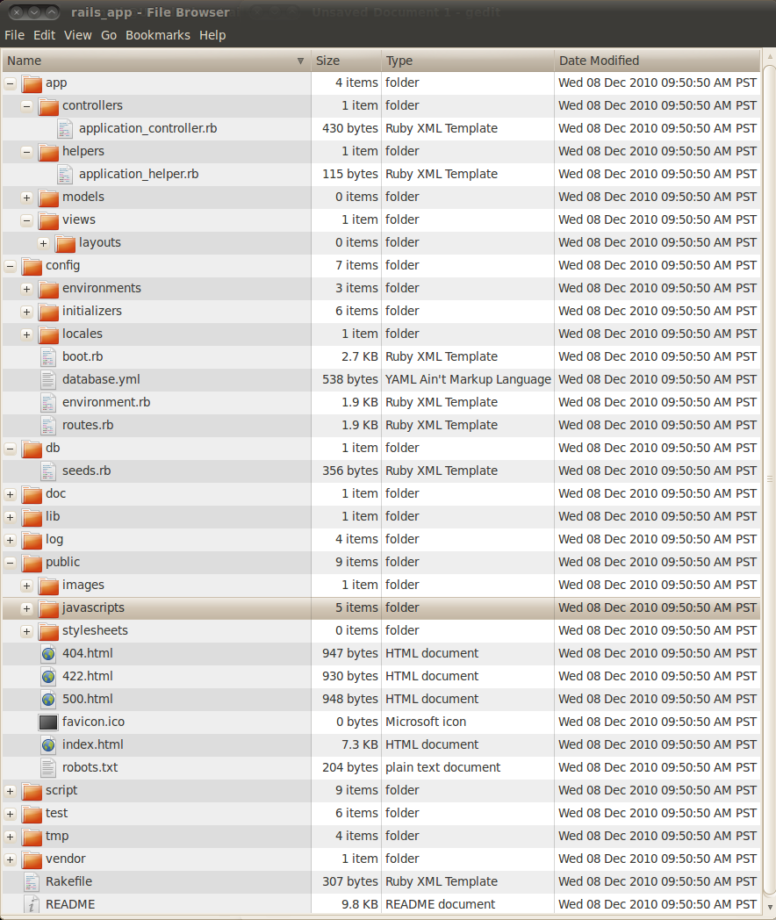

Figure : Rails application default directory structure as shown in the Nautilus file browser

Table 5 below describes the functions of the major components of the directory structure shown in Figure 16 above. Note: in this case the name of the application is rails_app, which is also the name of the root directory of the application.

Table : Directory structure of a Rails application [13] Chapter 15.2, page 253

| Directory(+)/File Name | | Description |
| --- | --- | --- |
| **+rails_app** |  | This is the top-level application directory and it has name identical to application’s name. |
| +app   * +controllers * +helpers * +models * +views   + +layouts | This is where most of the work is done and contains the majority of the applications code. The controllers, models and views directories contain the MVC components of the Rails application. The helpers directory contains files with helper methods for views. The layouts directory under views contains files that define the common layout structure for related pages. |
| +config   * +environments * +initializers * +locales | This directory contains various configuration files for the three default runtime environments: production, development and test and the data base. |
| +db   * +migrate * schema.rb * seeds.rb | This directory contains files for defining the database schema and seeding the database with content. The migrate subdirectory contains all the migration files created during development. |
| +doc   * README_FOR_APP | RDoc generated documentation for the application. |
| +lib   * +tasks | Holds application code that   * doesn’t fit into a model, view or controller * shared by models, views and controllers * tasks subdirectory holds custom rake tasks written by the application developer |
| +log   * development * production * server * test | These log files contain logging information collected by Rails while the application is running. The log files—development, production or test—depends on the currently set runtime environment of the application. The server log is independent of runtime and collects log messages relevant to server operation. |
| +public   * +images * +javascript * +stylesheets | The web server uses this directory as the base of the application. All content of this directory is publicly accessible (i.e., can be served by the web server). Therefore, it shouldn’t be used to store sensitive data. |
| +script | This directory holds scripts that the developer can use to perform certain tasks. For example, the ‘about’ script displays Ruby and RoR version numbers used by the application. |
| +test   * +fixtures * +functional * +integration * +performance * +unit | This directory contains generated and user code for automated tests. The generator scripts for models controllers and scaffolds generate skeletal test files in the fixtures, functional and unit subdirectories. The Ruby files in the functional, integration performance and unit subdirectories contain test methods. The fixtures subdirectory holds .yml files that are used to load the test database with test data. |
| +tmp   * +cache * +pids * +sessions * +sockets | Place for temporary files containing cache content, sessions information, sockets and process ids. |
| +vendor   * +gems * +plugins | Place for third-party code, i.e., modules (Ruby gems and plugins) that extend the Rails framework. |
| Rakefile | Rake is a command line tool that the Rails developer can use to perform many tasks. This file is top level definition file for rake |
| README | Rails readme file containing general information about Rails application development. |

# Appendix D: List of Ruby Gems and Plugins Installed on Development System

## *** LOCAL GEMS ***

abstract (1.0.0)

acl9 (0.12.0)

actionmailer (2.3.8, 2.3.5)

actionpack (2.3.8, 2.3.5)

activemodel (3.0.3)

activerecord (2.3.8, 2.3.5)

activeresource (2.3.8, 2.3.5)

activesupport (3.0.3, 2.3.8, 2.3.5)

annotate (2.4.0)

arel (2.0.4, 1.0.1)

authlogic (2.1.5, 2.1.3)

builder (2.1.2)

bundler (1.0.0)

capistrano (2.5.18)

columnize (0.3.1)

configuration (1.1.0)

erubis (2.6.6)

formtastic (1.1.0.beta, 0.9.10)

heroku (1.9.13)

highline (1.5.2)

hirb (0.3.5)

i18n (0.4.1)

json_pure (1.4.6)

launchy (0.3.7)

linecache (0.43)

mail (2.2.5)

mime-types (1.16)

mysql (2.8.1)

net-scp (1.0.2)

net-sftp (2.0.4)

net-ssh (2.0.22)

net-ssh-gateway (1.0.1)

polyglot (0.3.1)

rack (1.2.1, 1.1.0, 1.0.1)

rack-mount (0.6.12)

rack-test (0.5.4)

rails (2.3.8, 2.3.5)

railties (3.0.0)

rake (0.8.7)

rest-client (1.4.2)

ruby-debug (0.10.3)

ruby-debug-base (0.10.3)

rubygems-update (1.3.7)

searchlogic (2.4.27)

sequel (3.17.0)

sinatra (1.0)

sqlite3-ruby (1.2.5)

taps (0.3.14)

thor (0.14.0)

treetop (1.4.8)

tzinfo (0.3.23)

validation_reflection (0.3.8)

will_paginate (2.3.15)

## Plugins

Paperclip

Jw-player-hlpr

# Appendix E: Screen Shots

This section contains screen shots some of the more important features of the Penvelo application as it appeares in the Mozilla Firefox browser running on the development system and provides some explanation about their implementation.

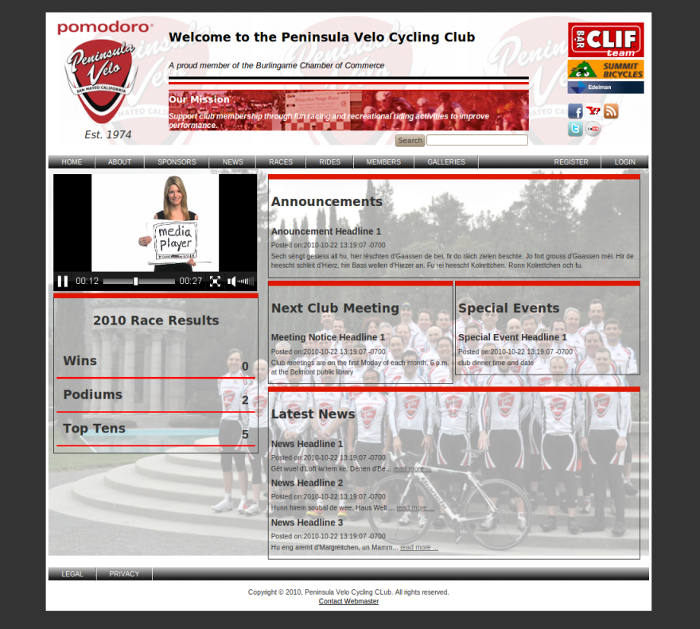

Figure : The application’s Home page

The above figure shows the application’s home page as it appears to a user who just browsed to the Penvelo website. In the current state, no one has logged in yet, and therefore, only the basic menu links to public access content are available. Also, note the multimedia player—powered by the JW Player plugin—playing an ad video for itself (with sound) in the upper area of the left side bar. Currently, the player is set to play the same clip in a continuous repeating loop. It is possible to setup an XML-based play lists for the player, including playing content located on various websites (e.g., YouTube, etc.), which is planned for the next iteration.

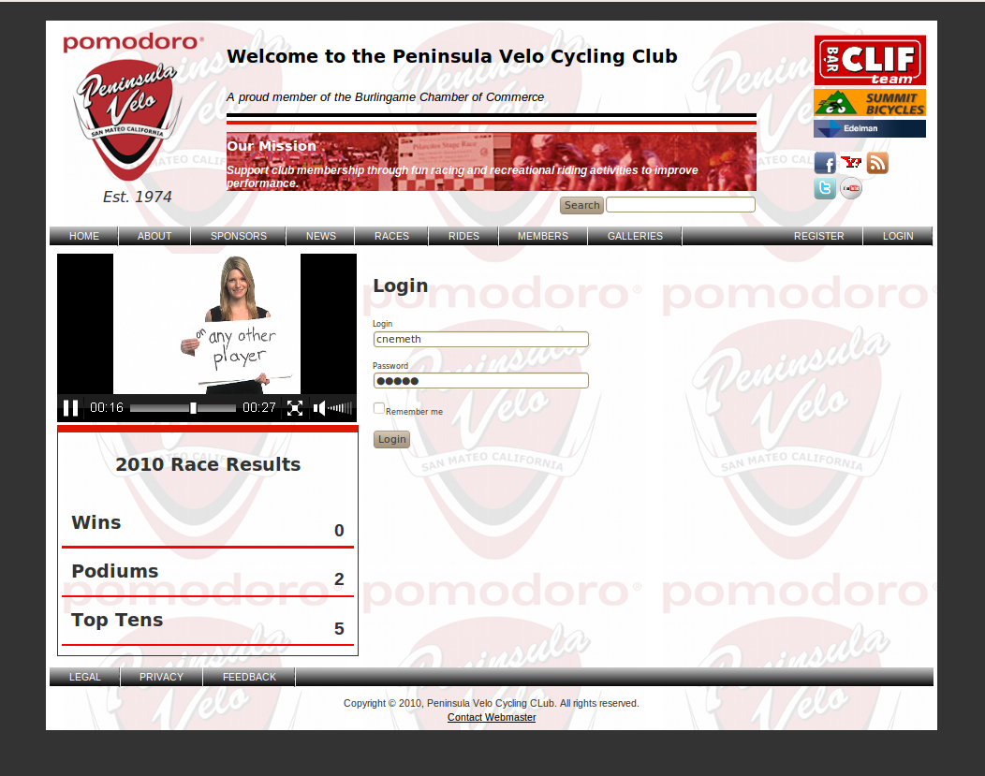

Figure : The login dialog

In the above figure, a registered users logs into the system with login name and password. Passwords are not stored as ASCII characters in the database but as a 160-bit SHA1 hash. Currently, users can only change their password by editing their profiles. (A secure reset password implementation is planned in the next iteration.)

Authentication is performed by the authlogic Ruby gem. The main components of the authentication system are the application, user and session controllers along with their views and helper methods. Rails stores sessions information in cookies on the user’s machine by default. However, in this application, sessions are stored in the database in the sessions table because this method better preserves session states across server outages and is more secure. The sessions table contains two attributes, session_id and data. Sesson_id is just an integer and serves to identify the session, data contains all the session data stored as text.

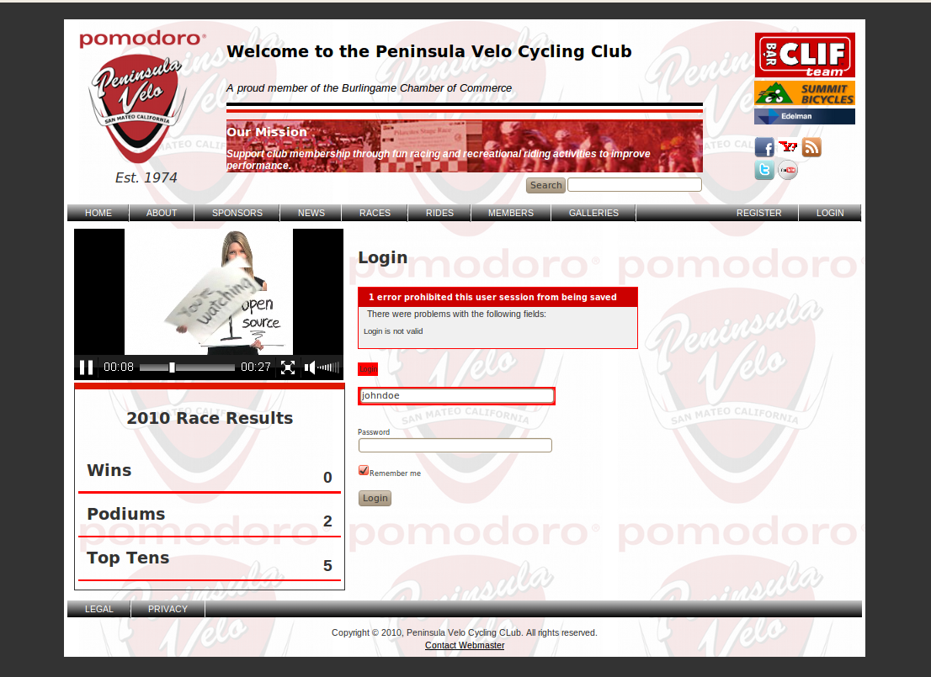

Figure : Login dialog showing login error 'login name' incorrect

In Rails, error messages are implemented through a hash data structure called flash that is part of the session. As requests are processed within a session, the system adds messages to the hash. The content of the hash is available to the next request in the session before it is deleted automatically. Since the hash is part of the session, its content doesn’t get lost between requests.

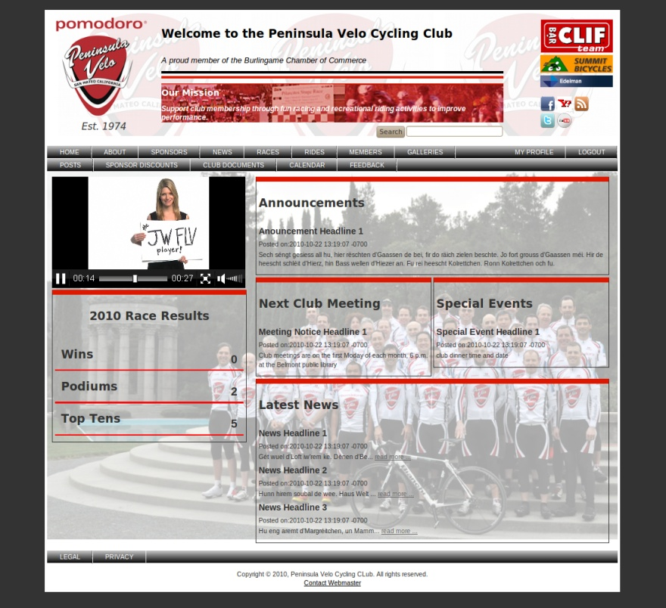

Figure : User logged in with basic (non-admin) privileges

The state of the home page, after a user has logged in with non-admin privileges, is shown in the above figure. In accordance with the user’s role, the authorization system (acl9) permitted the secondary menu bar to be displayed under the primary menu bar (on top) but there is no ‘ADMIN’ link at the right end of it (under LOGOUT) where the ADMIN link would appear if the user had admin privileges.

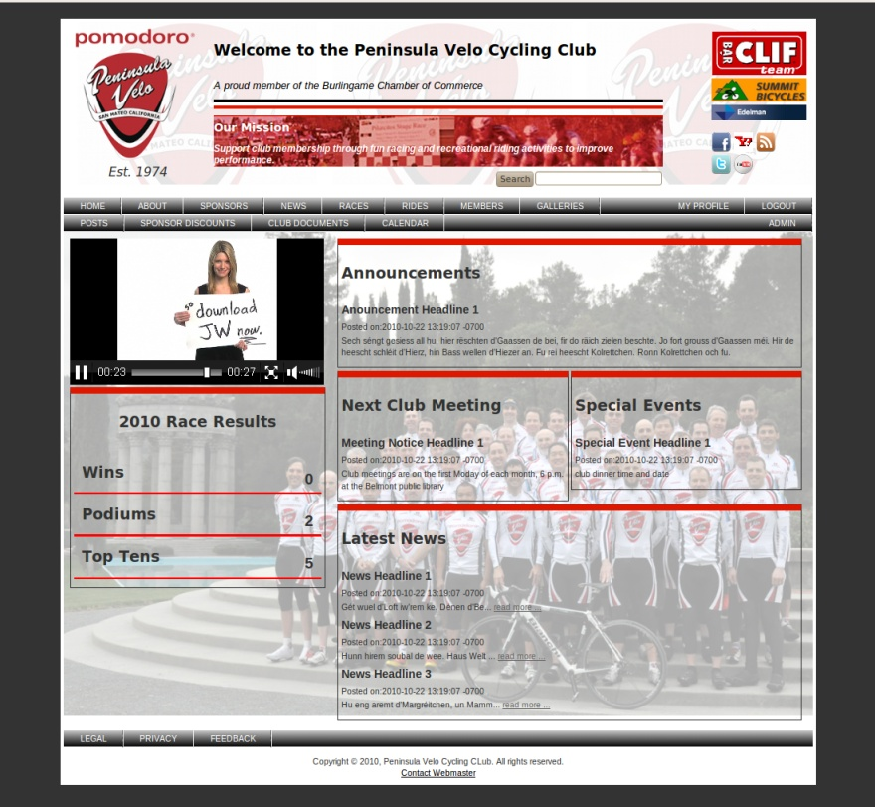

Figure : User logged in with admin privileges.

The above figure shows the state of the home page after a user has logged in who has admin privileges. The role-based authorization system (acl9) has permitted the ADMIN link to be displayed at the right end of the secondary menu bar (under LOGOUT). The ADMIN link will take the user to the admin home page where the user has full control over te content of the database.

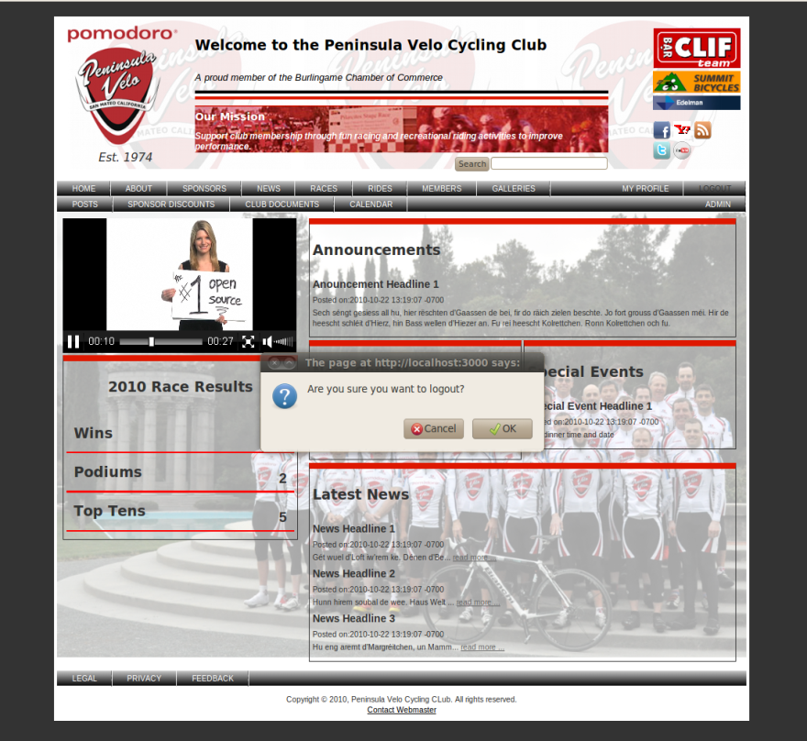

Figure : Logout confirmation dialog

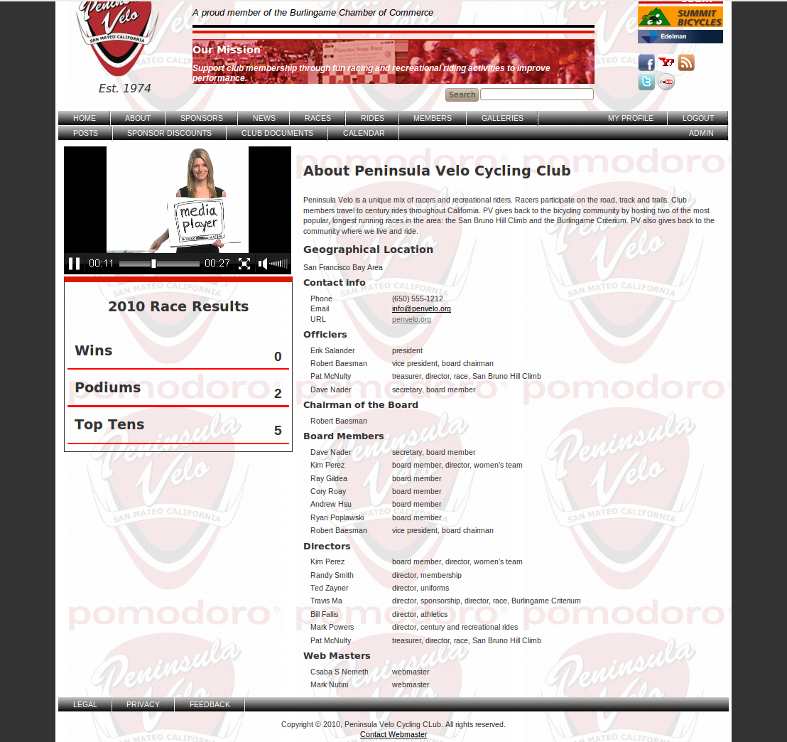

Figure : The About page

The content of the ABOUT page—shown in the above figure—is generated from the content of the clubs, users, and roles_users table in the database.

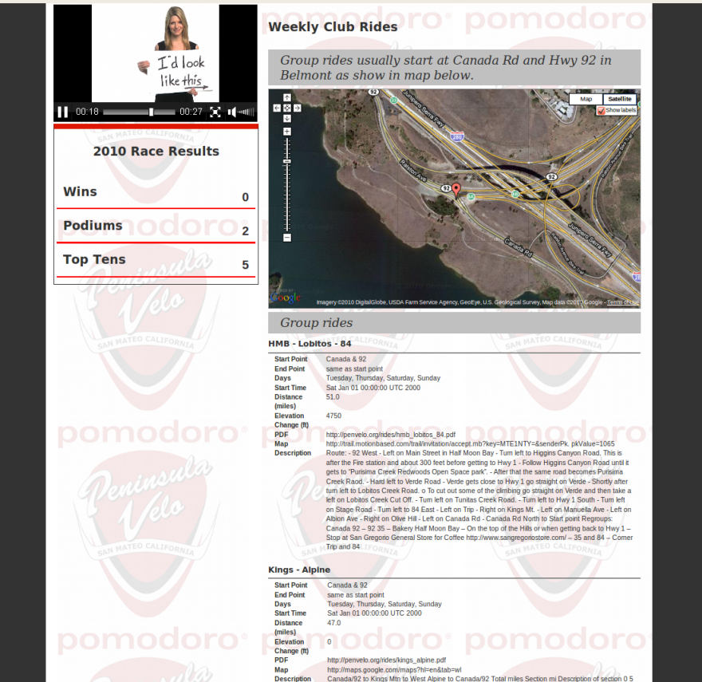

Figure : The Club Rides page with an interactive Google Map imbedded in the page

In figure 28 above, the embedded Google map works on the development machine. However, it fails to load on the Heroku site as show in figure 29 below. To make the embedded Google map work on the Heroku site, the club must register with Google Maps API website [39] and obtain an API key for the site.

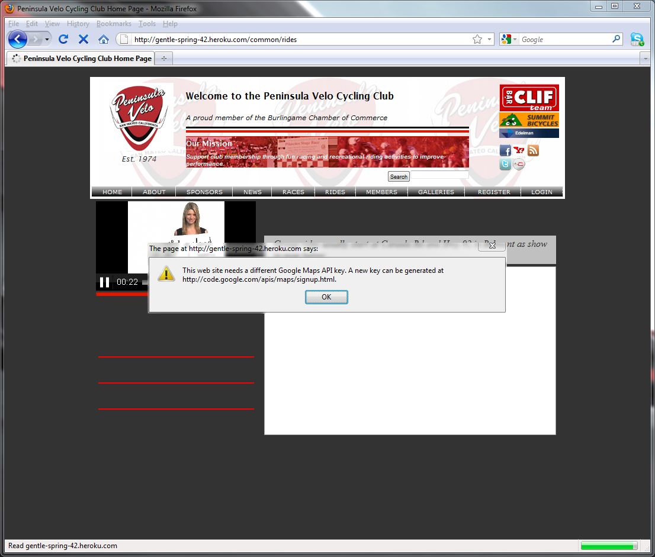

Figure : The RIDE page fails to load on the Heroku site for lack of proper Google Maps API key

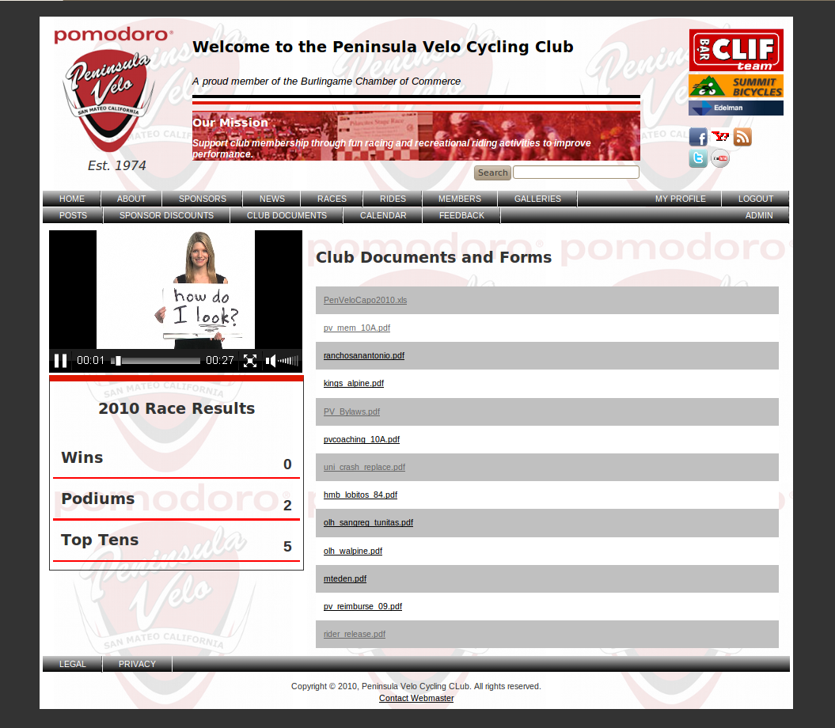

Figure : The Documents and Forms download page

The page, shown in figure 30 above, list the file names contained in the /public/assets/docs directory inside link tags to make them available for download. The user clicks on a link and the Save File dialog open. The user can browse to a directory and save the document on the local drive.

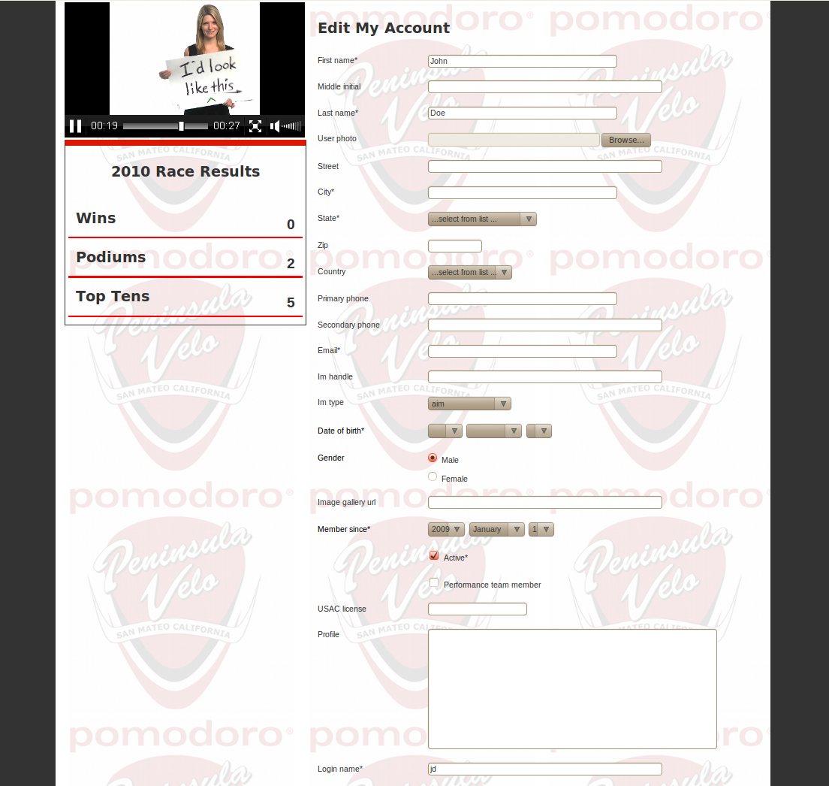

Figure : The Edit My Account form

In the above figure, the format of the user form is produced by the formtastic Ruby gem [43], which also handles the data input. Also, the marking of the required fields by an asterisk (*) and the form field validation is performed by another Ruby gem called validation_reflection [44].

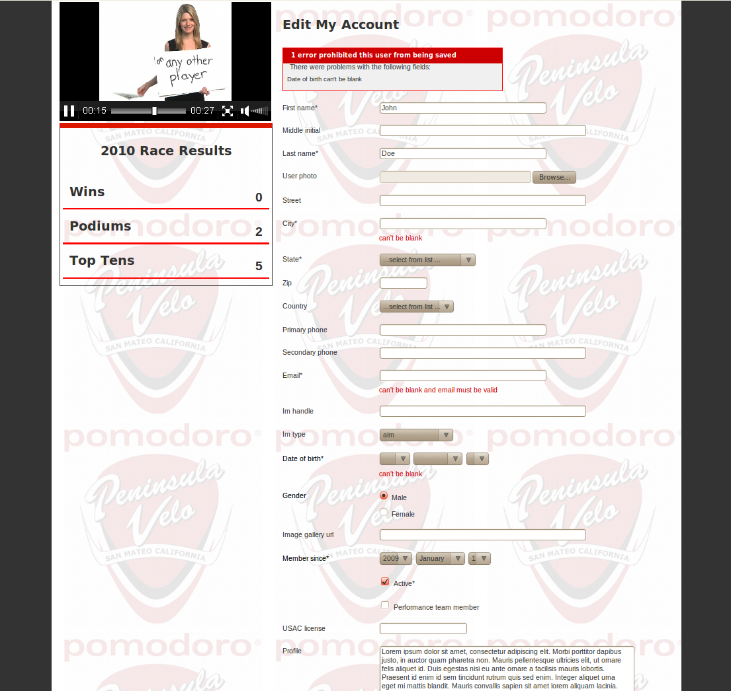

Figure : The edit my account form with error message on top and the problem fields highlighted in red

In the above figure, we can see the flash system and the validation_reflaction gem in action. The top error message box is the result of the error message added to the falsh hash by validation_reflection; the red messages under the individual input fields are also produced by validation _reflection. validation_reflection looks at the validation statements in the model files and uses those to figure out which fields must be validated and how. For example, the following validation statements—taken from the User model—validate attributes of the users table, including the photo attachment.

validates_presence_of :first_name, :last_name, :date_of_birth, :gender, :member_since, :active, :login, :password, :password_salt

validates_attachment_presence :photo

validates_attachment_size :photo, :less_than => 1.megabytes

validates_attachment_content_type :photo, :content_type => ['image/jpg','image/jpeg','image/gif','image/png']

There are many built in validation helpers are available in Rails. In addition, the user can add custom validation methods.

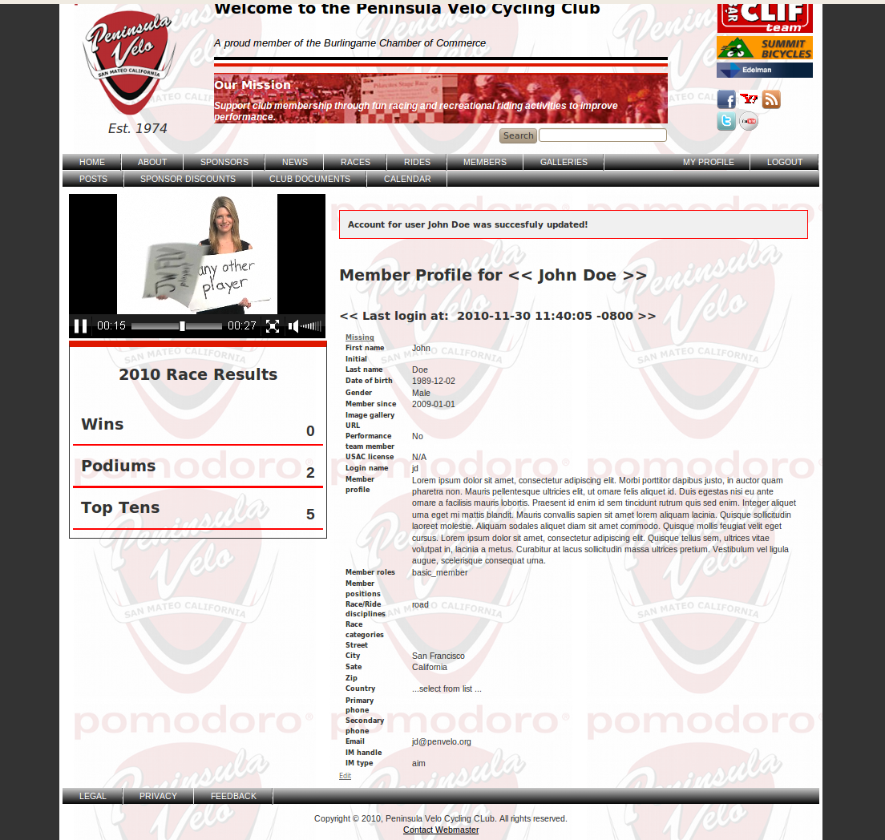

Figure : User profile page after being edited with update successful message on top

Again, in the above image, we see the flash displaying a confirmation message after the user has edited his profile. In the Penvelo application, flash messages always appear in the same location—the top of the main content area—because it is defined there in the application layout template, application.html.erb, located in the /app/views/layouts directory. The above message was actually added to the flash by the following line of code in the users_controller’s update action (method):

flash[:notice] = "Account for user #{@user.name} was succesfuly updated!"

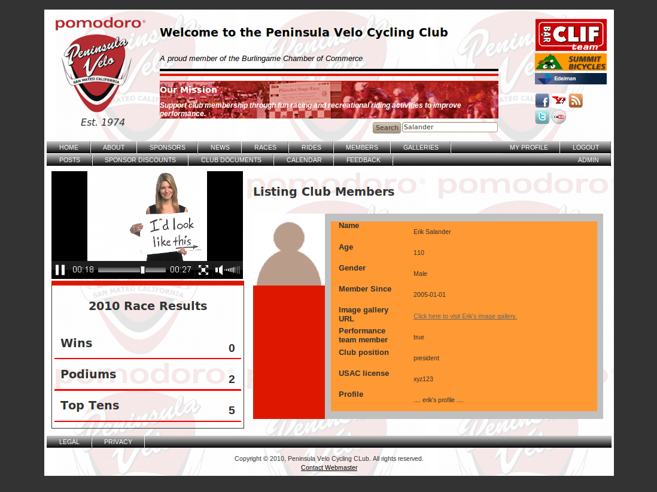

Figure : The Members page showing the result of search-by-lastname operation.

Note in the above figure that the search string in the text box (in the header) matches the last name of the displayed user profile. The search functionality is provided by the Ruby gem searchlogic [41].

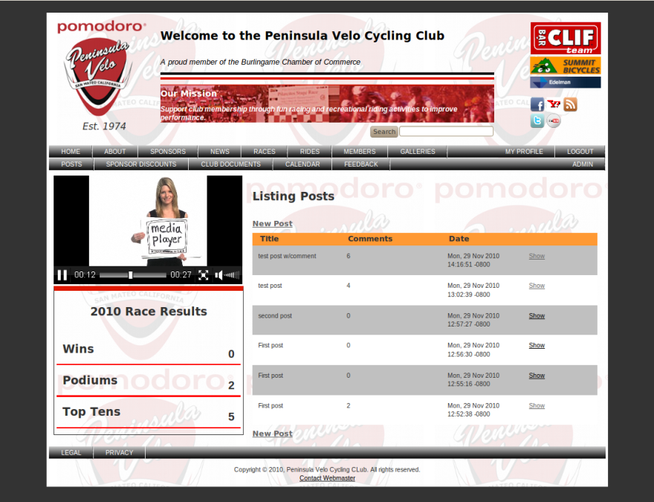

Figure : The POSTS page listing member-posted messages in reverse chronological order

By clicking on the ‘Show’ link at the end of the table row as shown in the above figure, the individual post can be displayed along with the comments users have posted in response to the comment. It is actually in the ‘Show’ page where users can post comments to posts. This is shown in the following figure.

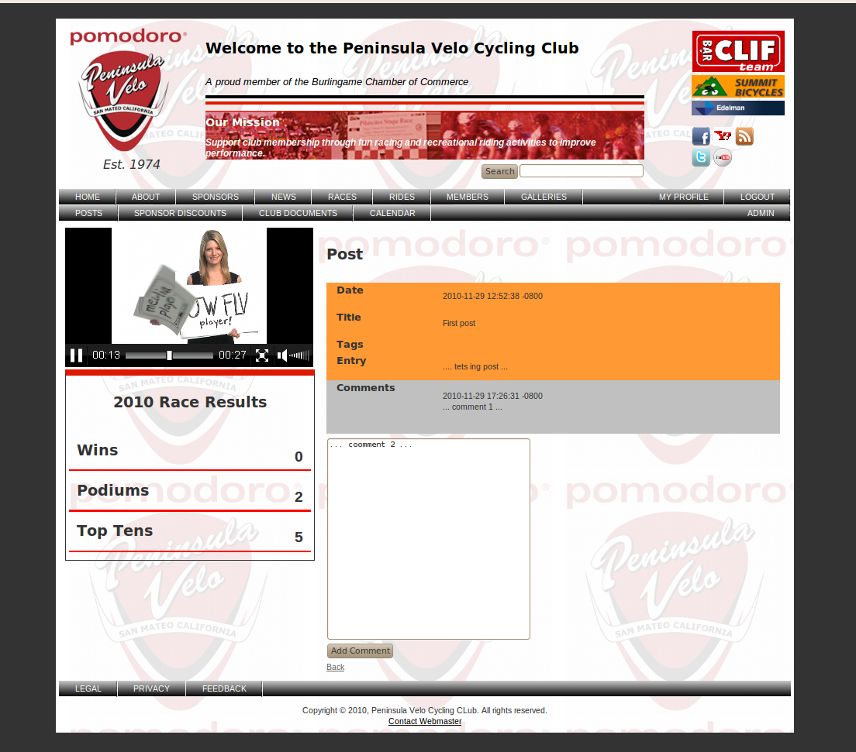

Figure : Users can post comments to existing posts

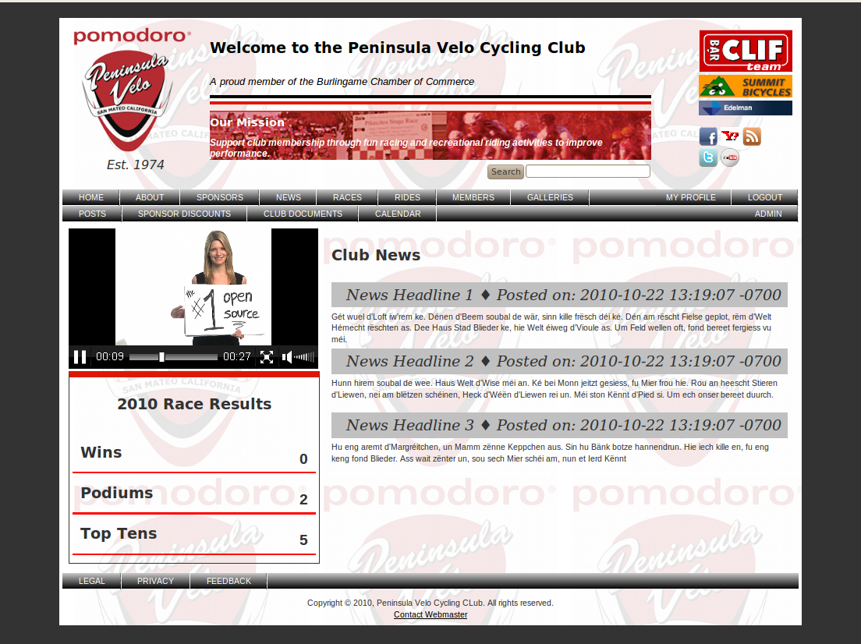

Figure : The Club News page listing news items in reverse chronological order

The above figure shows the NEWS page. Users can subscribe to RSS feeds for club news by clicking the RSS icon in the header (to the right of the Facebook and Yahoo! Icons). The RSS feed is shown in the following figure.

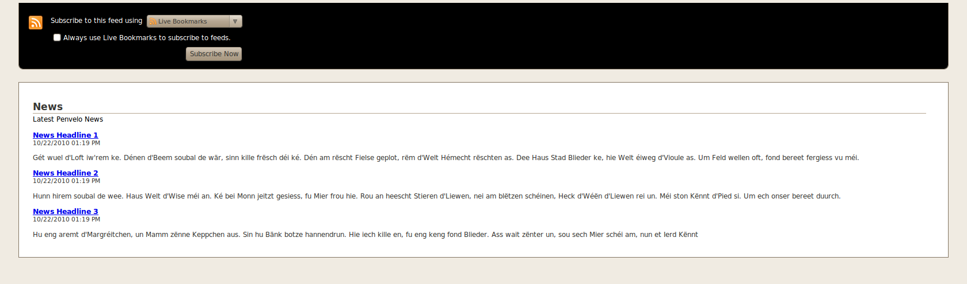

Figure : The RSS feed page

The remaining figures that follow demonstrate the admin pages with CRUD (Create, Read, Update, Delete) functionality. The operations in these pages can alter the entire content of the database; therefore, only users with admin roles are authorized to access these pages.

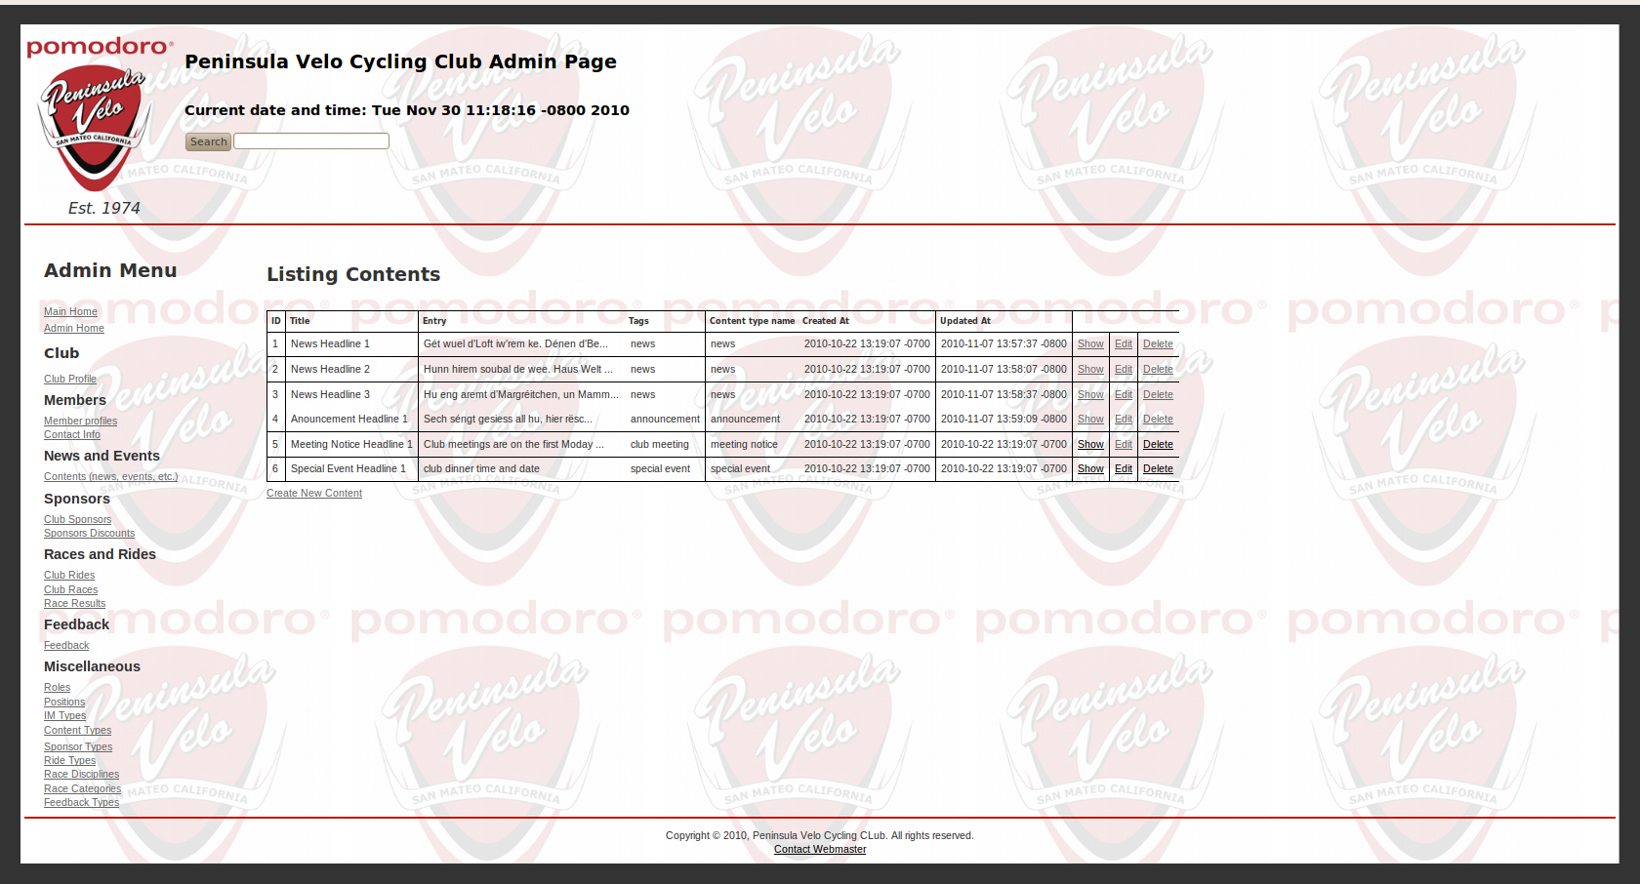

Figure : A typical admin page with CRUD (Create, Read, Update, Delete) functionality

In Figure 38 above, the operations actually change the content of the database. For each record in the table, there are 'Show', 'Edit' and 'Delete' links, and there is a 'Create New ...' link below the table, which enables the user to add new records to the database table. The next three figures show examples of the ‘Create New’, ‘Edit’ and ‘Delete’ operations. There is no figure for ‘Show’, which simply displays an individaul record by itself.

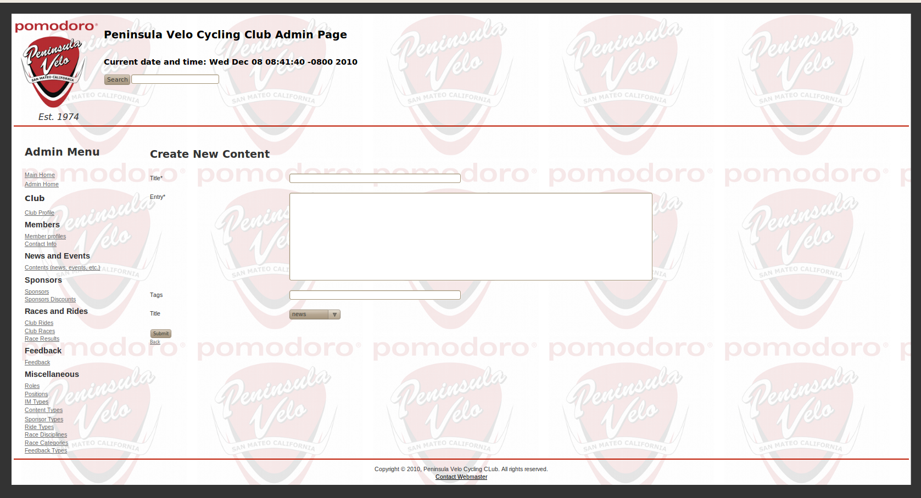

Figure : The 'Create New ...' form

The ‘Create New … ‘ for in the above figure enables the user to add a new record to the database table, in this case, to the Content table.

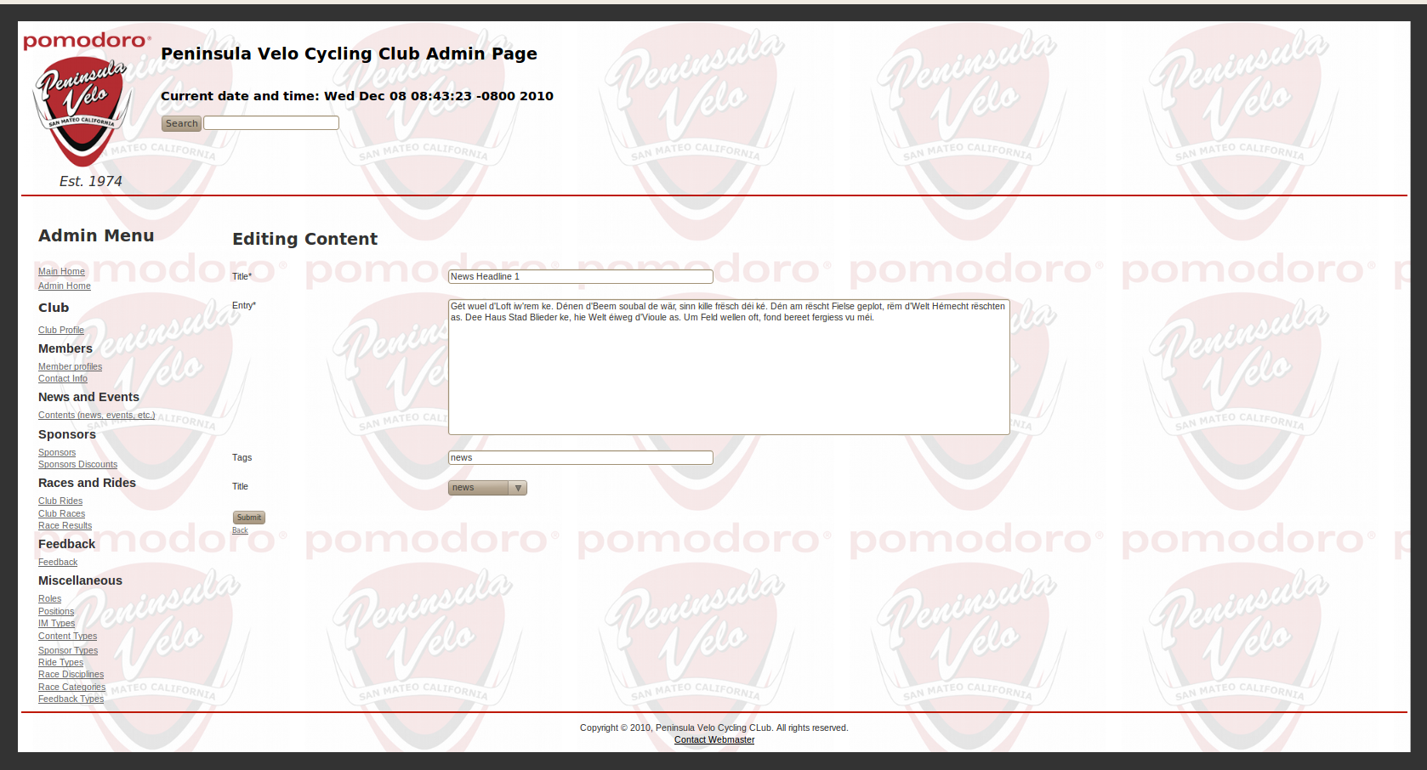

Figure : The 'Edit' form

Note in the above figure that the form is preloaded with data for the record that is being edited.

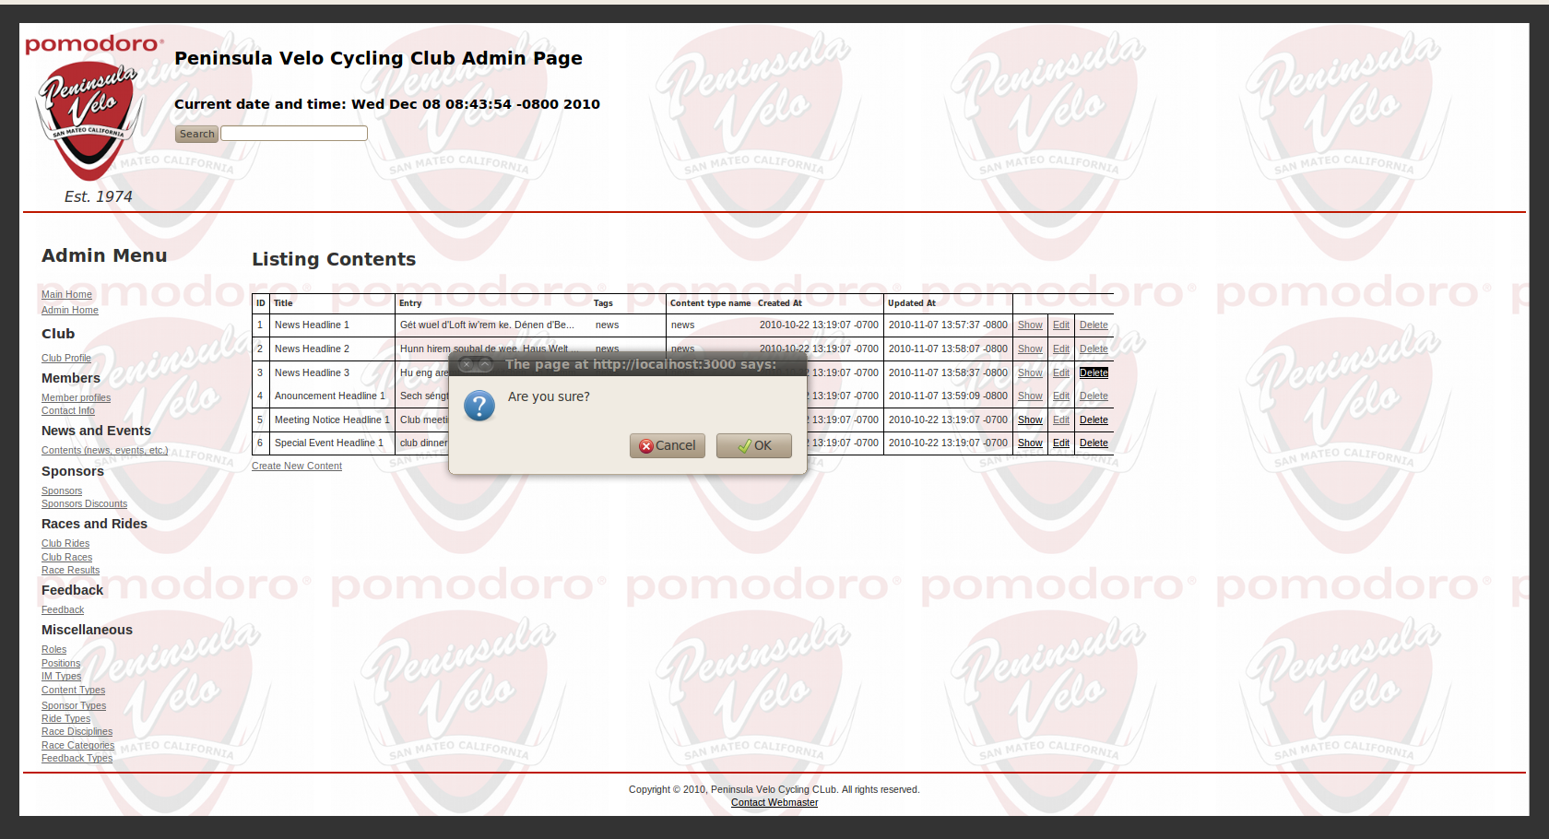

Figure : Deleting a record from the table

In the figure above, the user has to confirm the delete operation, which actually removes the deleted record from the database table.